# 

# **From Chapter 1**

# **French Defense - Minor Variations**

**Game # 8**

**A.Shirov (2740) – E.Bareev (2675) C00**

Novgorod 1994

**1.e4 e6 2.d3 d5 3.Nd2 Nf6 4.Ngf3 b6 5.c3 c5 6.g3 Ba6 7.c4 dxe4 8.dxe4 Bb7 9.Bg2 Qc7 10.e5**

10.0–0 Nc6 11.e5 Nd7 12.Ne4 0–0–0 13.Bg5 Nf6 14.exf6 Rxd1 15.Raxd1 gxf6 16.Bxf6 Rg8 17.Rd2 with an unclear position and chances to both sides, Gajewski-Skrzypnik, Bartkowa 2002.

**10...Ng4 11.0–0 Nc6 12.Ne4 Rd8 13.Qa4 Qd7 14.Bg5**

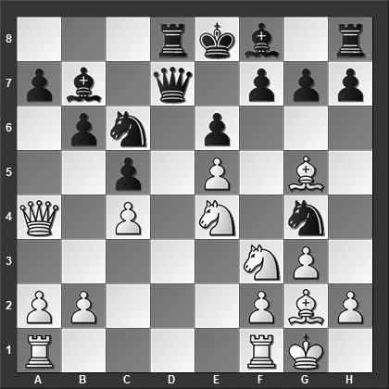

*What happens on 14...Ncxe5?*

**14...Ncxe5??**

Black should have played 14...Nd4, and now:

15.Qxd7+ Rxd7 16.Nxd4 Rxd4 17.Rad1 h6 18.Rxd4 cxd4 19.Bf4 g5 20.h3 gxf4 21.hxg4 Bxe4 22.Bxe4 fxg3 23.Bc6+ Kd8 24.fxg3 Ke7 and Black has the marginally better chances in the endgame.

15.Qd1 Bxe4 16.Nxd4 Bxg2 17.Kxg2 Nxe5 (17...cxd4 18.Qxg4 Rc8 19.Rad1 h6 20.Bc1 Rxc4 21.Qe4) 18.Bxd8 cxd4 19.Bg5 Bc5 20.Qe2 f6 21.Bf4 Nf7 with chances to both sides.

**15.Rad1!** Black resigned because he will lose at least a piece, e.g., 15.Rad1, and now:

a) the queen cannot be captured 15...Qxa4 16.Rxd8#.

b) 15...Nxf3+ 16.Bxf3 Ne5 17.Rxd7 Rxd7 (17...Nxf3+ 18.Kg2 Rxd7 19.Kxf3) 18.Bg2 and Black can resign.

c) 15…Bd5 16.Qxd7+ Rxd7 17.cxd5 and White is simply a piece up

**1–0**

# **From Chapter 2**

# **French Defense - Advance Variation**

**Game # 18**

**P.Svidler (2733) – A.Shirov (2713) C02**

Leon 2004

**1.e4 e6 2.d4 d5 3.e5 c5 4.c3 Qb6 5.Nf3 Bd7**

By playing this move before committing to ...Nc6, Black signals his intention to play ...Bb5, exchanging the light-squared bishops.

**6.Be2**

An alternative for White is 6.Bd3, intending to meet 6...cxd4 with 7.Nxd4, preventing ...Bb5 for now.

**6...Bb5**

A popular alternative is 6...cxd4 7.cxd4 Bb5 8.Nc3 , e.g., 8...Bxe2 9.Nxe2 Ne7 10.0–0 Nec6 11.Rb1 a5 12.Nf4 Nd7 13.Be3 Be7 with chances to both sides, Svidler-Gelfand, Rishon Le Ziyyon 2006.

**7.dxc5**

The two main lines are 7.0–0 and 7.c4, each having been played in hundreds of games.

**7...Bxc5 8.b4?!**

This is brave but almost certainly not the best. Instead 8.0–0 Bxe2 9.Qxe2 Qa6 10.Qd2 Nh6 11.b4 Be7 12.Nd4 Nd7 13.Re1 Ng4 14.f4 h5 15.a4 with a tiny plus for White, Movsesian-Ionov, Dagomys 2009.

**8...Bxf2+**

At first glance, this capture looks like a no-brainer, but the bishop is quite vulnerable on f2 and getting it back to safety is far from easy. The alternative, however, promises White the better chances: 8...Bf8 9.0–0 Bxe2 10.Qxe2 Qa6 11.b5 (11.Qd2 Nd7 12.Na3 Ne7 13.Nd4 Nxe5 14.Nab5 Rc8 15.Qe2 Nc4 was okay for Black in Kabanov-Volkov, Moscow 2012) 11...Qa4 12.Nfd2 Nd7 13.c4 dxc4 14.Nxc4 Rc8 15.Nbd2 Nh6 16.Qf3 and White has better chances, Mestel-Weidemann, Groningen 1976.

**9.Kf1 Bd7**

Black cannot play 9...Bxe2+ because after 10.Qxe2 the bishop on f2 is trapped. However, 9...Bc6! seems promising for Black, for instance:

10.Qd3? a6 11.a4 Ne7 12.Ra2 was played in Kristjansson-Thorsson, Icelandic Team Ch 1998, and now Black could have played 12...Qa7! intending ...Bb6 with a good game for Black.

10.Qd2!? Nh6! 11.Qf4? (White should have played 11.a4!? a6 12.Bd3 Ng4 13.Qg5 h5 14.a5 Qa7 15.Ke2 although Black should be doing rather well after 15...Nd7) 11...Nf5 12.Bd3 Be3 13.Bxe3 Qxe3 14.Qxe3 Nxe3+ with an advantage for Black, Larsson-Nyander, Swedish Team Ch 1992.

**10.Qd2?!**

This is almost certainly wrong. White should instead have played the aggressive 10.c4!, and now:

10...dxc4?? 11.Na3 a6 12.Nxc4 Qa7 was played in Yemelin-Sharankov, Tallinn 2009, and here White could have won with 13.Nd6+ Ke7 14.Qd2 Nc6 15.b5 axb5 16.Nxb5 Qc5 17.Qd6+ Kd8 18.Qc7+ Ke7 19.a4.

10...Na6! 11.c5 Nxc5 12.bxc5 Bxc5 (12...Qxc5 13.Nbd2 is better for White) 13.Nc3 (13.Nbd2 Ne7 14.Nb3 Ba4 (14...Bb5 15.Nxc5 Qxc5 16.Rb1 Bxe2+ 17.Qxe2 doesn't provide Black sufficient compensation for the piece) 15.Rb1 0–0 16.g3 f6 17.exf6 Rxf6 18.Bg5 Rf7 19.Kg2 e5 with a sharp position and chances to both sides) 13...Ne7 14.Na4 (14.Rb1 Qc7 15.Nb5 Bxb5 16.Bxb5+ Nc6 17.Qc2 is insufficient for Black) 14...Bxa4 15.Qxa4+ Nc6 16.Bd3 and White should have the somewhat better chances.

**10...Nh6 11.Bd3??**

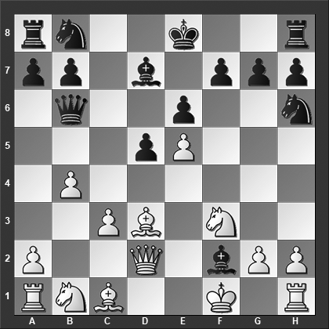

*We have a messy position on the board and Black’s bishop on f2 looks like it may be in trouble. How should Black best continue?*

Now White loses. He had to try 11.c4!?, and now:

11...Ng4 12.Qg5 (or 12.c5!? Bxc5 13.bxc5 Qxc5 14.Bd3 Bb5 15.Bxb5+ Qxb5+ 16.Qe2 Qxe2+ 17.Kxe2 Nc6 18.Bb2 is somewhat better for White) 12...Be3 13.Qxg7 Bxc1 (13...Rf8 14.c5 Qd8 15.Nc3 with a clear advantage for White - Psakhis) 14.Qxh8+ Ke7 15.c5 Qxb4 16.h3 Ne3+ (16...Bb2?? 17.hxg4 Bxa1 18.Qf6+ Ke8 19.Nbd2 wins for White - Psakhis) 17.Kf2 Qxc5 18.Qf6+ Ke8 19.Qh8+ with a draw by perpetual check - Psakhis in *ChessBase Magazine*.

11...Nc6!? 12.c5 Qxb4 13.Kxf2 Qxc5+ 14.Ke1 Ng4 15.Rf1 Rc8 16.Ba3 Qe3 17.Nc3 Na5 promises Black good compensation for the piece.

11...Na6?! 12.a4! (12.c5 Nxc5 13.bxc5 Bxc5 provides Black excellent compensation for the piece) 12...Nxb4 13.a5 Qc7 14.Kxf2 Ng4+ 15.Kf1 Qc5 16.Qd4 and White is clearly better.

**11...Ng4! 12.Qg5?**

This loses for White. The alternatives are:

12.h3 Ne3+ (12...Be3 is also good) 13.Ke2 Nf5 14.Bxf5 exf5 intending ...Bg3 with a large, possibly winning, advantage for Black.

12.Qf4 f5! (12...Be3 13.Bxe3 Nxe3+ 14.Ke2 Nf5 15.g4 Nh6 16.Nbd2 0–0 is clearly better for Black) 13.exf6 (13.h3 Be3 14.Bxe3 Nxe3+ 15.Ke2 Nxg2 followed by ...f5–f4 with a large advantage for Black) 13...Nxf6 14.Qe5 (14.Ke2 0–0 is winning for Black) 14...Bb5 15.Bxb5+ Qxb5+ 16.Qe2 Qxe2+ 17.Kxe2 Bb6 with a clear advantage for Black.

**12...Bb5!**

Both 12...Bg1 and 12...Be1 also win for Black.

**13.c4**

Or 13.Qd2 0–0 (13...Bxd3+ 14.Qxd3 Be3 15.Bxe3 Qxe3 also wins for Black according to Psakhis) 14.Bxb5 Be3 15.Qe2 Bxc1 and White is busted.

**13...Bg3!** White resigned. After 13...Bg3 14.Qd2 Bf4 15.Qe2 Bxc4 16.Bxc4 Bxc1 17.Bb5+ Nc6 Black should win rather easily.

**0–1**

# **From Chapter 3**

# **French Defense - Tarrasch Variation: 3.Nd2**

**Game # 30**

**G.Timoscenko (2540) – P.Dittmar (2325) C06**

Seefeld 1997

**1.e4 e6 2.d4 d5 3.Nd2 Nf6 4.e5 Nfd7 5.Bd3 c5 6.c3 Nc6 7.Ne2 Qb6 8.Nf3 cxd4 9.cxd4 f6 10.exf6 Nxf6 11.0–0 Bd6 12.Nc3 Bd7 13.a3**

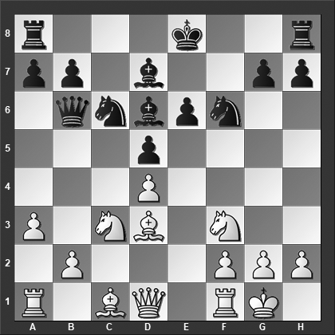

*Can Black get away with capturing the pawn on d4?*

**13...Nxd4**

The main line is 13...0–0 14.Be3 Be8 15.Ng5 Bd7 (or 15...Ne7 16.h3 Bc7 17.Na4 Bxa4 18.Qxa4 Nf5 19.Rac1 Nxe3 20.fxe3 Qd6 21.Rxc7 Qxc7 22.Nxe6 Qe7 23.Nxf8 Qxe3+ 24.Kh2 Qxd3 with more or less equal chances, Ye Jingchuan-Zhang Zhong, Shanghai 2000) 16.Na4 Qc7 17.h3 h6 18.Nf3 Be8 19.Rc1 Bh5 20.Be2 Rac8 21.b4 Qf7 22.Nc5 b6 23.Nd3 Ne4 24.Nfe5 Bxe2 25.Qxe2 Bxe5 26.Nxe5 Nxe5 27.dxe5 was played Ruggeri Laderchi-Holmberg, ICCF email 2006, and now 27...Rc7 intending doubling of the rooks on the c-file; Black has the better chances.

**14.Nxd4 Qxd4 15.Bg6+??**

For those unfamiliar with this variation may be unaware of this trap and think that Black just blundered by allowing the text move, winning the queen. But, as we will see, it turns out White is the side blundering when playing this move. Instead, the main line is 15.Nb5 Qe5 16.g3 (or 16.f4 Bc5+ 17.Kh1 Qb8 18.b4 Bb6 19.Bb2 0–0 20.Qe2 Kh8 21.Rf3 Bxb5 22.Bxb5 was Andreev-Sitnikov, Serpukhov 2003, and now 22...Qd6 23.Re1 Rac8 when White has compensation for the sacrificed pawn but not more than that) 16...Bxb5 17.Bxb5+ Kf7 18.Re1 Qf5 19.Bd3 Qh3 20.Bf1 Qf5 21.Bd3 Qh3 22.Bf1 Qf5 and draw agreed, ½–½, Xie Jun-M. Kuijf, Wijk aan Zee 1998; after 23.Be3 Rhc8 24.Bd3 Qh5 25.Be2 Qf5 26.Bd3 the players will repeat moves for the draw to be the consequence.

**15...hxg6** And White resigned, realizing that after 16.Qxd4 Bxh2+ 17.Kh1 Be5+ 18.Kg1 Bxd4, he is simply a piece down, as seen, for example, in Nolting-Murphy, 1996. A shocking oversight by a grandmaster, but one seen in at least five other games.

**0–1**

# **From Chapter 4**

# **French Defense - Various 3.Nc3 Variations**

**Game # 45**

**K.Mekhitarian (2546) – M.Macedo (2408) C10**

Brazilian Ch (Montenegro) 2013

**1.e4 e6 2.d4 d5 3.Nc3 dxe4 4.Nxe4 Nf6 5.Nxf6+ Qxf6 6.Nf3 h6 7.Bd3 Nc6 8.0–0 Bd6 9.c3 0–0 10.Nd2!?**

10.Qe2 is more commonly seen in this position, but Black should be okay after 10...e5 11.Qe4 g6 12.Nxe5 Nxe5 13.dxe5 Bxe5 14.Re1 Re8 15.Bf4 Bf5 16.Bxe5 Bxe4 17.Bxf6 Bxd3 with more or less equal chances, Pyrich-Ciornas, ICCF email 2010.

**10...e5**

Or 10...Qh4 11.g3 Qd8 12.Ne4 Be7 13.Qe2 b6 14.Bf4 Bb7 15.Rad1 Rc8 16.f3 and White has the better chances, Gofshtein-Rosell, Dos Hermanas 2003.

**11.Ne4!**

The point behind the previous move, White now grabs the initiative. In another outing, White tried 11.d5?! Nb8?! (Black should have played 11...Ne7 12.Ne4 Qg6 13.Nxd6 Qxd6 14.c4 Rd8 with something close to equality) 12.f4 Bf5 13.Nc4 Bxd3 14.Qxd3 exf4 15.Nxd6 Qxd6 16.Bxf4 and White is clearly better, Baklan-Keller, Metz 2000.

**11...Qg6**

Black has also tried 11...Qd8 12.Qh5 (my computer gives preference to 12.Nxd6 cxd6 13.Bc2 with an initiative for White, but White's continuation in the game is also interesting) 12...exd4 13.Bxh6 gxh6 14.Qxh6 Bf5 15.f4 Re8 16.Nxd6 Re6

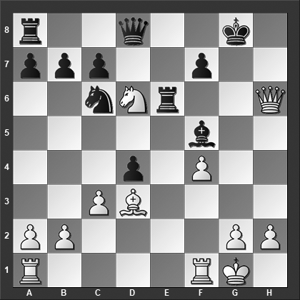

*This was played in Gufeld-Alburt, Soviet Union 1974, and here White missed a strong continuation, can you do better?*

17.Qh8+! Kxh8 18.Nxf7+ Kg7 19.Nxd8 Rxd8 20.Bxf5 which would have left him clearly better.

**12.f4** Or 12.Nxd6 Qxd6 13.dxe5 Nxe5 14.Bc2 Qf6 15.Qd5 Re8 16.Qe4 Qg6 17.Bf4 Qxe4 18.Bxe4 g5 19.Bg3 f5 20.Bd5+ Kg7 21.f4 c6 22.Bb3 Nd3 23.Rad1 Nc5 24.Bc2 Ne4 25.fxg5 hxg5 26.Rfe1 Kf7 27.Bxe4 fxe4 28.Bf2 and here a draw was agreed upon, ½–½, in Graham-Stubbe, ICCF email 2007, after both players having followed the engine best moves for quite a while. Structurally, White still has the better position, but Black should be able to defend.

**12...Bf5??**

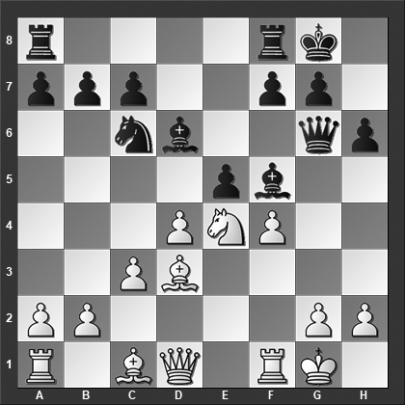

*What is White’s best move?*

A gruesome blunder based on the pin of the knight. Black should have played 12...exd4! which leads to a good game for Black, e.g., 13.f5 Bxf5 14.Rxf5 Bxh2+ 15.Kxh2 Qxf5 16.Ng3 Qf6 and Black has clearly better chances.

**13.Nf6+! Qxf6**

Everything loses, e.g., 13...Kh8 14.Bxf5 Qxf6 15.fxe5 or 13...gxf6 14.Bxf5 Qxf5 15.fxe5 Qd7 16.exd6 f5 17.dxc7 and Black's position falls apart.

**14.fxe5!**

The point.

**14...Bg4**

This is silly, but even the better 14...Qd8 15.Rxf5 Be7 16.Qg4 is a disaster for Black who cannot adequately defend against White's aggressive pieces on the kingside.

**15.Qxg4** Black resigned.

**1–0**

# **From Chapter 5**

# **French Defense - Winawer Variation:**

# **3.Nc3 Bb4**

**Game # 77**

**D.Vargic (2297) – G.Mufic (2364) C16**

Croatian Team Ch (Pula) 2000

**1.e4 e6 2.d4 d5 3.Nc3 Bb4 4.e5 b6 5.Qg4 Bf8 6.Bg5 Qd7 7.Nh3**

White has several much more frequently played options, including 7.Nf3, 7.f4, 7.0–0–0, and 7.Bb5.

**7...h5!?**

The alternatives are:

7...Ba6 8.Bxa6 Nxa6 9.0–0 Nb4 10.a3 Nc6 11.b4 h6 12.Be3 Nce7 13.Nf4 Qc6 14.Nd1 (14.Nce2!?) 14...a5 15.bxa5 Rxa5 when despite lacking a bit behind in development, Black is okay, Salgado Lopez-Lopez Martinez, Calvia 2007.

7...Nc6 8.0–0–0 Bb7 9.f4 h6 10.Bh4 h5 11.Qf3 Nge7 12.Bg5 Nf5 13.Qf2 Be7 (here Black has already equalized; now White should have exchanged on e7 to maintain equal chances...) 14.Bb5? f6 15.exf6 gxf6 16.Bh4 0–0–0 17.Ng1 was played in Volke-Dizdar, Austria 2002, and now 17...Nxh4 18.Qxh4 e5 19.Nge2 a6 and Black has grabbed the initiative.

7...h6 8.Be3 Nc6 9.a3 Bb7 10.Bd3 0–0–0 11.Nf4 Kb8 12.0–0 Nge7 13.b4 Nf5 14.Nce2 g6 and draw agreed, which, although premature, is in an equal position, ½–½, Luther-Schlosser, Lippstadt 2000.

**8.Qf3 Ne7 9.Bxe7 Bxe7 10.Nf4 g6 11.Bd3**

White can also consider 11.Bb5 c6 12.Bd3 Bb7 13.Rd1 although Black should be pretty close to equal in this position.

**11...Rg8 12.0–0–0 Ba6?**

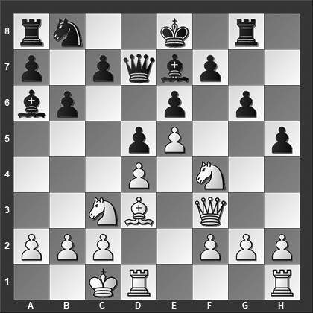

*How should White best continue?*

Black wants to exchange the "bad French bishop". The better option is the normal 12...Bb7 13.h4 Nc6 when White at best is slightly better.

**13.Ncxd5!! exd5 14.e6! fxe6 15.Bxg6+** Here Black resigned which is wildly premature. After 15.Bxg6+ Rxg6 (or 15...Kd8 16.Bf7 Rg4 17.Kb1 Bb4 18.Nxe6+ Kc8 19.Bxh5 with a large advantage for White) 16.Qxh5 Bd6 17.Qxg6+ Qf7 18.Qxe6+ Qxe6 19.Nxe6 White has an advantage, but Black can still fight.

**1–0**

# **From Chapter 6**

# **Caro-Kann Defense - Main Lines:**

# **3.Nc3 dxe4 4.Nxe4**

**Game # 97**

**D.Paulsen (2431) – R.Appel (2481) B15**

German Bundesliga 2001

**1.d4 g6 2.e4 Bg7 3.Nc3 c6 4.Nf3 d5 5.exd5**

5.h3 is considered the best move and the main line. White's move is rather tame and Black equalizes without further ado.

**5...cxd5 6.Bb5+**

6.h3 Nc6 7.Bf4 Nf6 8.Bd3 0–0 9.Qd2 Re8 (Black doesn't have any problems after 9...Qb6 which is probably Black's best) 10.0–0 a6 11.a3 Be6 12.Rfe1 Qd7 13.Na4 Nxd4 14.Nxd4 Qxa4 15.Nxe6 fxe6 16.Rxe6 and White has the better chances, Stefanova-Khotenashvili, Beijing 2014.

**6...Bd7**

Or 6...Nc6 7.Ne5 Bd7 8.Nxd7 Qxd7 9.Be3 a6 10.Be2 Rd8 11.Bf3 e6 12.Ne2 Nge7 13.c3 Nf5 and Black has a comfortable game, Tryggestad-Maze, Fornebu 2017.

**7.Qe2 Nf6 8.Bg5**

8.Ne5 Nc6 9.Nxd7 Qxd7 10.0–0 a6 11.Bxc6 Qxc6 12.Re1 0–0 13.Bg5 e6 14.Rad1 b5 with a comfortable position for Black, Wuts-Okhotnik, Le Touquet 2002.

**8...a6 9.Bd3 Nc6 10.0–0 Bg4 11.Be3 0–0**

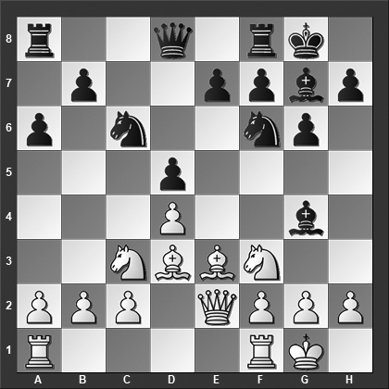

*Why is 12.h3 now a mistake?*

**12.h3??**

White should have played 12.Rfe1 although Black has the initiative after 12...e5 13.dxe5 Nxe5 14.Bd4 Nc6 15.Bxf6 Bxf6 16.Qd1 Nd4

**12...Bxf3 13.Qxf3 e5!** White resigned because of the dual threats of ...e5–e4 and ...e5xd4. If 14.dxe5 Nxe5 15.Qf4 then 15...Nh5 16.Qb4 Nxd3 17.cxd3 d4 wins the piece.

**0–1**

# **From Chapter 7**

# **Caro-Kann Defense - Panov Attack**

**Game # 108**

**V.Bologan (2585) – J.Borges Mateos (2470) B13**

Linares 1999

**1.e4 c6 2.d4 d5 3.exd5 cxd5 4.c4 Nf6 5.Nc3 Nc6 6.Nf3 Bg4 7.cxd5 Nxd5 8.Qb3 Nb6 9.d5 Bxf3 10.gxf3 Nd4 11.Bb5+ Nd7 12.Qa4 e5??**

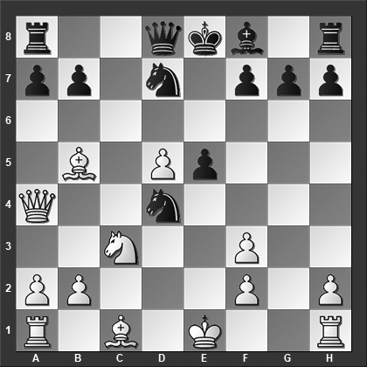

*This turns out to be a blunder - can you find the refutation?*

The alternatives are fully playable for Black:

12...Nxb5 13.Qxb5 g6 14.0–0 Bg7 15.Re1 0–0 16.Bg5 Bxc3 (or 16...Re8?! 17.d6 Bf6 18.dxe7 Rxe7 19.Rxe7 Bxe7 20.Rd1 Bxg5 21.Rxd7 Qf6 22.Qxb7 Re8 23.Kg2 and despite his open king, White is in charge and eventually won the game, Potkin-Wang Hao, Ningbo 2010) 17.bxc3 f6 18.Bf4 Rf7 19.Rad1 b6 20.Qe2 Rc8 21.c4 Nc5 22.Bc1 Qd7 with fairly even chances in this strategically complicated position, Solak-Kovalenko, St Petersburg 2013.

12...Nxf3+ 13.Kd1 a6 14.Bxd7+ Qxd7 15.Qe4 Qh3 16.Qa4+ Qd7 17.Qe4 Qh3 18.Ke2 Nh4 19.Bg5 (19.Be3 f5 20.Qf4 Rd8 21.Rag1 Ng2 22.Qg5 Nxe3 23.Rg3 Qh6 24.Qxh6 gxh6 25.fxe3 Rd6 26.Rf1 Rf6 and the chances are about even, Korneev-Zelcic, Cutro 2003) 19...Nf5 20.Qa4+ Kd8 21.Ne4 Qg4+ 22.Kd3 Nd6 23.Qa5+ Kd7 24.Qa4+ Kd8 and after repeating the checks a few times, the players settled on a draw, Grigoryan-Gagunashvili, Quezon City 2014.

**13.dxe6! Nxe6 14.Bg5!!**

This is the refutation. It has to be pointed out that Yusupov when encountering the position did not find 14.Bg5!! and instead played 14.Be3 a6 15.Bxd7+ Qxd7 16.Qxd7+ Kxd7 17.0–0 Bd6 18.Nd5 Rad8 19.Rac1 Nc7 20.Nb6+ Ke6 21.Rfe1 Kf5 22.Red1 Ne6 when Black despite his far advanced king is doing okay although he eventually misplayed and lost the game, Yusupov-Timoscenko, Kislovodsk 1982.

**14...Nxg5**

A couple of other tries have been made:

14...Nec5 15.Bxd8 Nxa4 16.Bxa4 Rxd8 17.0–0–0 Be7 18.Rxd7 Rxd7 19.Rd1 Bg5+ 20.Kc2 and Black resigned, 1–0, Stets-Bets, Voronezh 2009.

14...Be7 15.Bxe7 Qxe7 16.0–0–0 0–0–0 17.Qxa7 (White can do even better with 17.Nd5! Qg5+ 18.f4 Qh4 and only now 19.Qxa7 when he is completely winning) 17...Nb8 18.Kb1 Qc5 19.Qa4 Nd4 20.Rc1 Nbc6 21.Bxc6 bxc6 22.Ne4 and White has a winning position, Carnic-Zivkovic, Belgrade 2008.

**15.0–0–0** Black resigned as he loses at least a couple of pieces trying to avoid mate.

**1–0**

# **From Chapter 8**

# **Caro-Kann Defense - Advance Variation**

**Game # 124**

**E.Berg (2516) – F.Langheinrich (2360) B12**

Pardubice 2002

**1.e4 c6 2.d4 d5 3.e5 Bf5 4.Nc3 Qb6 5.Bd3 Bxd3 6.Qxd3 e6 7.Nge2 Qa6 8.Qh3 c5?**

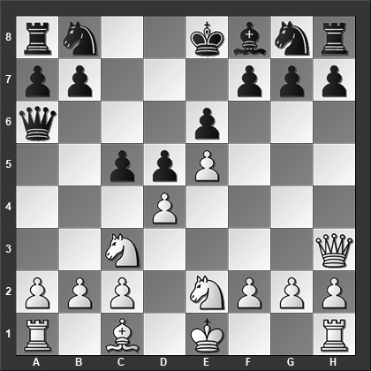

*What is White’s best move?*

The text move is rather logical which also makes it a common mistake. The better alternatives are:

8...Nd7 9.0–0 Ne7 10.a4 Rc8 11.Be3 Qb6 12.a5 Qd8 13.a6 b5 14.f4 g6 15.g4 f5 16.exf6 Nxf6 was played in Nataf-Bagheri, Montpellier 2006, when 17.Rae1 Bg7 18.g5 Nh5 19.Qxe6 Qd7 20.Qxd7+ Kxd7 leaves White a pawn up but Black has positional compensation.

8...Ne7 9.Be3 Nd7 10.f4 g6 11.g4 h5 12.Ng3 c5 13.f5 cxd4 14.Bxd4 Bh6 15.fxg6 fxg6 and Black has a comfortable game, Holmsten-Dreev, Ubeda 1999.

**9.Nxd5! exd5**

Or 9...Qa5+ 10.Qc3 Qxc3+ 11.Ndxc3 and White is simply a pawn up.

**10.Qc8+**

Now White is winning.

**10...Ke7 11.Qxc5+ Ke8 12.Qc8+ Ke7 13.Bd2**

Or 13.Bg5+ f6 14.exf6+?? (14.Bd2! wins for White) 14...Nxf6 (14...gxf6! 15.Bd2 Kf7 is basically okay for Black) 15.0–0 Qc6 16.Bxf6+ gxf6 17.Qf5 Qe6 18.Qh5 Qf7 19.Qf3 Nc6 20.Nf4 with a strong, on-going initiative for White in Asaturian-Khodos, Soviet Union 1969; the game where this opening trick made its first appearance.

**13...Qb5**

The alternatives are no better:

13...Qb6 14.Nf4 and Black resigned, 1–0, Olesen-Vadasz, Budapest 1994.

13...Nc6 14.Qxa8 Nh6 15.Qc8 and Black resigned, 1–0, Neukirch-Kuhn, Gemuend 1999.

**14.Nc3** Black resigned.

**1–0**

# **From Chapter 9**

# **Caro-Kann Defense - Minor Lines**

**Game # 136**

**M.Dutreeuw (2394) – D.Sadkowsky (2262) B12**

Belgian Team Ch (Antwerp) 1999

**1.e4 c6 2.d4 d5 3.f3 e6 4.Nc3 Bb4 5.Qd3 Ne7 6.a3**

6.Bf4 is the main line.

**6...Ba5 7.Be3**

White has a full-good alternative in 7.Bd2 Nd7 8.f4 0–0 9.e5 c5 10.b4 cxd4 11.Nb5 Bb6 12.Nf3 Nc6 13.Ng5 g6 14.Qh3 h5 15.g4 f6 16.Nf3 when White has the better chances; the Black kingside is very loose, Arribas Lopez-Abhishek, Moscow 2016.

**7...Nd7**

Another try is 7...dxe4 8.Qxe4 (8.fxe4!? seems like a good, logical alternative that may well be better for White) 8...Nf5 9.Bf2 Nd7 10.Nge2 Nf6 11.Qd3 h5 12.g3 Nd5 13.Rg1 Qe7 14.f4 Bd7 15.Bg2 g5 16.0–0–0 0–0–0 with a dynamic position where both sides have their share of the chances, Mednikova-Solovjova, St Petersburg 2009.

**8.Nge2 0–0 9.Nc1?!**

Or 9.0–0–0 b5 10.Bf4 Bb6 with chances for both sides, although it seems Black's pawns on the queenside will connect with White's pawns in front of the king well before White, can come up with anything elsewhere.

**9...e5 10.Nb3**

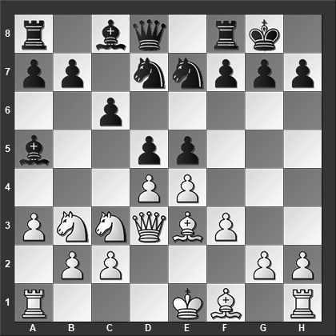

*How should Black best continue?*

**10...c5!**

This is incredibly strong, basically winning a piece although White will get something in return.

**11.Nxa5 exd4 12.Nb3**

White's best is something along the lines of 12.Bg5 Ne5 13.Qd2 dxc3 14.Qxc3 when Black still picks up material but White gets good counterplay, e.g., 14...f6 15.0–0–0 b6 16.Nc4 Nd7 17.Bf4 dxc4 18.e5 fxe5 19.Bxc4+ Kh8 20.Bxe5

**12...dxc3 13.bxc3??**

Here White should have played 13.Qxc3 d4 14.Nxd4 cxd4 15.Bxd4 Re8 16.Bxg7 Nd5 17.Qd2 Kxg7 18.Qxd5 when he has three pawns in return for the piece. The text move, however, is just poor...

**13...c4** White resigned.

**0–1**