# 

# **From Chapter 1**

# **Scotch Game & Gambit**

**Game # 9**

**A.Khasin – A.Lilienthal C45**

Moscow Ch 1955

**1.e4 e5 2.Nf3 Nc6 3.d4 exd4 4.Nxd4 Bc5 5.Be3 Qf6 6.c3 Nge7 7.Bc4 Ne5 8.Be2 d5 9.0–0 h5**

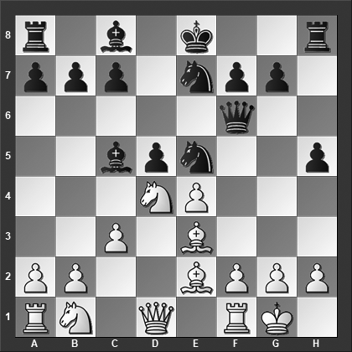

*Black plays aggressively, intending to throw ...Ng4 in White's face. How should White best meet this move?*

In our next main game, we will discuss the main line 9...0–0 10.Nd2.

**10.Nb5! Qb6**

Or 10...Bxe3 11.Nxc7+ Kf8 12.fxe3 Qg5 13.Nxa8 Ng4 14.Bxg4 hxg4 15.Qe1 and White is winning, Kotsur-Logunov, Krasnoyarsk 1998.

**11.Bxc5 Qxc5 12.Qd4!** The elegant refutation of Black's play. Black resigned as he cannot prevent material losses.

**1–0**

# **From Chapter 2**

# **Italian Game & Evans Gambit**

**Game # 26**

**J.Cubas (2419) – G.Milos (2592) C54**

Sao Paulo 2003

**1.e4 e5 2.Nf3 Nc6 3.Bc4 Nf6 4.d3 Bc5 5.c3 0–0 6.0–0 d6 7.Bb3 Kh8 8.Re1 Ng4 9.d4 exd4 10.h3 Nge5 11.Nxd4 Qh4 12.Bc2**

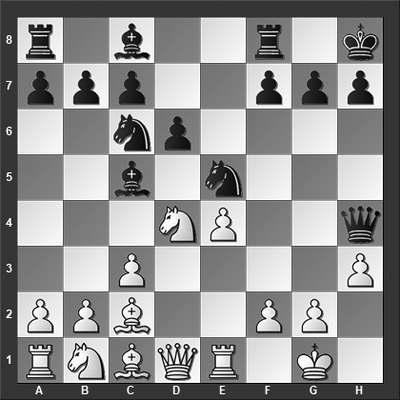

*What is Black's best move?*

White should have played 12.Be3 f5 13.exf5 Bxf5 14.Nxc6 Nxc6 15.Qd2 Bxe3 16.Qxe3 Ne5 which is better for Black but at least playable for White.

**12...f5!**

After this move, White is completely busted.

**13.b4**

Another possible continuation is 13.exf5 Nxd4 14.cxd4 Bxd4 15.Re2 Bxf5 16.Bxf5 Rxf5 17.Be3 Bxe3 18.fxe3 Raf8 19.Nd2 Rf2 and Black penetrates White's king position.

**13...Bb6 14.f4 Nxd4** White resigned. After 14...Nxd4 15.cxd4 Bxd4+ White can resign anyway. **0–1**

# **From Chapter 3**

# **Two Knights Defense**

**Game # 40**

**B.Stein (2375) – K.Langeweg (2395) C56**

European Team Ch (Plovdiv) 1983

**1.e4 e5 2.Nf3 Nc6 3.Bc4 Bc5 4.c3 Nf6 5.d4 exd4 6.0–0 Nxe4 7.cxd4 Be7?!**

7...d5! is the main line and better move.

**8.d5 Nb8 9.Re1 Nd6 10.Bd3 0–0 11.Nc3 Ne8**

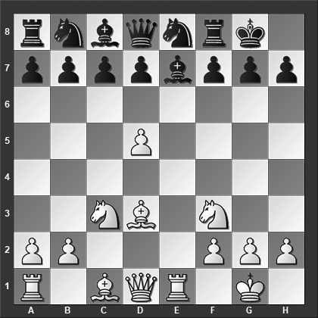

*How should White best continue?*

11...Na6 is called best by my computer although here too White is better: 12.Be3 b6 13.Qc2 f5 14.a3 and White has excellent compensation for the pawn.

11...Bf6 12.Bf4 is also quite uncomfortable for Black.

**12.d6! cxd6**

Black should have played 12...Bf6 but then 13.Nd5 Nxd6 14.Qc2 Nc6 15.Bxh7+ Kh8 16.Bf4 is terrible for Black.

**13.Bxh7+ Kxh7 14.Rxe7 Qxe7 15.Nd5** Black resigned. If Black's queen is to avoid knight forks she has to return to d8 but then Black gets mated.

**1–0**

# **From Chapter 4**

# **Four Knights**

**Game # 47**

**S.Kuipers (2399) - Zhao Xue (2568) C46**

Caleta 2014

**1.e4 e5 2.Nf3 Nc6 3.Nc3 Nf6 4.a3 Nd4 5.d3**

The position on the board is already extremely rare, however, it seems like White's best option is 5.Bc4 Bc5 (5...Nxf3+?! seems wrong somehow, e.g., 6.Qxf3 c6 7.d3 d6 8.0–0 Be7 9.Qe2 0–0 10.f4 Nd7 11.f5 Bg5 12.Bxg5 Qxg5 13.Rf3 Nf6 14.Raf1 and White has marginally better chances, Pinski-Alvarado Rodriguez, Warsaw 2011, but White can also consider 6.gxf3!? followed by Rg1 with interesting play) 6.Nxe5 d5 7.Nxd5?! (White should probably play 7.Bxd5 Nxd5 8.Nxd5 0–0 9.Ne3 when Black has to prove sufficient compensation for two pawns) 7...Nxd5 8.c3 Nf4 9.cxd4 Qxd4 10.0–0 Qxe5 11.d4 Nh3+ 12.gxh3 Bxd4 with better chances for Black, Moraru-Mateuta, Bucharest 1999.

**5...Bc5 6.Nxe5 d5! 7.Bg5 h6**

Black can also consider 7...Qd6 8.Nf3 dxe4 9.dxe4 Qb6 with good counterplay.

**8.Bh4 g5!?**

Black is playing aggressively to demonstrate compensation.

Or 8...c6!? but after 9.Be2 0–0 10.0–0 Qe7 11.Nf3 g5 12.Bg3 White seems to have the better chances.

**9.Bg3 Qe7 10.Be2 Be6 11.Ng4?**

This is definitely mistaken. After 11.Nxd5 Nxd5 12.exd5 Bxd5 13.0–0 0–0 14.Re1 Black has very little to show for his sacrificed pawn.

**11...Bxg4 12.Bxg4 dxe4 13.0–0?!**

White is getting himself deeper into trouble, but it is hard to fault him for not liking 13.Be2 0–0–0 14.0–0 h5 15.h3 Nf5 16.Bh2 e3 17.f3 which looks ridiculous for White.

**13...h5! 14.Bxh5 Nxh5 15.Nd5**

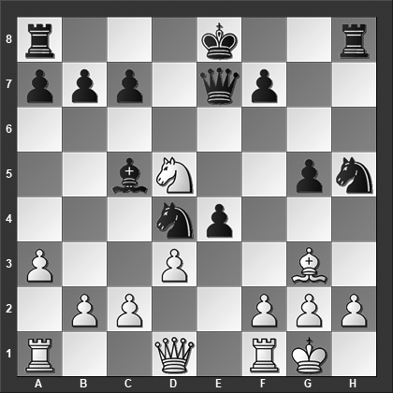

*How should Black best continue?*

**15...Nxg3!** Black has other good moves, but this is the best and since White now resigned, it is not up for debate either!

**0–1**

# **From Chapter 5**

# **Ruy Lopez without 3…a6**

**Game # 82**

**A.Machulsky (2450) – V.Malaniuk (2520) C67**

Alma-Ata 1989

**1.e4 e5 2.Nf3 Nc6 3.Bb5 Nf6 4.0–0 Nxe4 5.d4 Nd6 6.Bxc6 dxc6 7.dxe5 Ne4 8.Qe2 Bf5 9.Be3 Qe7 10.Na3**

White has a couple of alternatives at this juncture:

10.Re1 Bg6 11.Nbd2 Nxd2 12.Qxd2 Qe6 13.Qa5 Be7 14.Qxc7 Qc8 15.Qxc8+ Rxc8 16.c3 and White's extra pawn should guarantee his reasonable winning chances, Tseshkovsky-Malaniuk, Alma-Ata 1989.

10.Rd1 h6 11.Na3 (11.Nbd2!? looks like a clear improvement for White) 11...g5 12.Nd4 Bg6 13.Qf3 Qxe5 14.Nxc6 Qxb2 15.Nc4 Qf6 16.Qxf6 Nxf6 17.Bd4 Bg7! and Black has the upper hand, Kindermann-Westerinen, Thessaloniki ol 1988.

**10...g5?!**

Black should consider 10...Bg4!? 11.Nc4 Qe6 12.Rad1 Be7 with chances to both sides.

**11.Nc4**

11.Nd4 Bg6 12.Nc4 transposes to the game.

**11...Bg6 12.Nd4 Bg7 13.Rad1**

13.Nb3!? is probably stronger, intending f2–f3.

**13...0–0–0??**

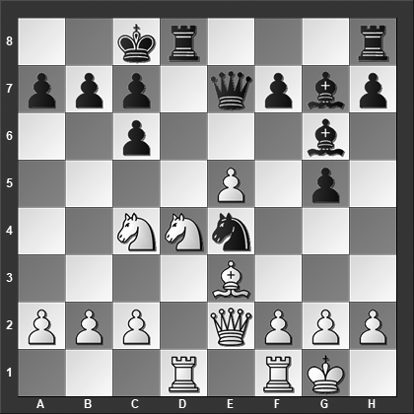

*How should White continue?*

13...0–0 14.f3 Nc5 looks playable for Black. After the text move, it is rapidly over.

**14.Nxc6!! bxc6 15.Na5** Black resigned.

**1–0**

# **From Chapter 6**

# **Ruy Lopez with 3…a6**

**Game # 107**

**A.Lukovnikov – Al.Ivanov (2470) C91**

Simferopol 1989

**1.e4 e5 2.Nf3 Nc6 3.Bb5 a6 4.Ba4 Nf6 5.0–0 Be7 6.Re1 b5 7.Bb3 d6 8.c3 0–0 9.d4 Bg4 10.Be3**

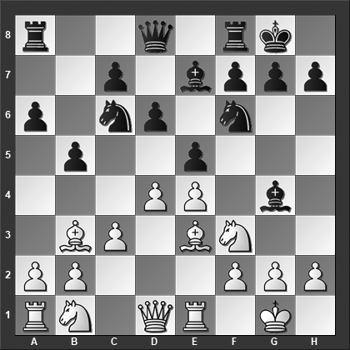

*This tactical exercise is a little tricky. Black made the following calculation: 10...Nxe4 11.Bd5 (forking the two knights) 11...Qd7, and now 12.Bxe4 can be answered with 12...d5 followed by 13...e4 when the pin wins back the piece. Has Black missed anything in that calculation? And what if White plays 12.dxe5 instead, where should e4–knight go? To c5 or g5? Try to work out the answers without moving the pieces on the board.*

**10...Nxe4 11.Bd5 Qd7 12.dxe5!?**

On 12.Bxe4 d5, and now:

13.Bxh7+ Kxh7 14.dxe5 Qf5 (14...Kg8 15.Nbd2 b4 is okay for Black) 15.Bd4 Bxf3 16.Qxf3 Qxf3 17.gxf3 Rae8 18.Nd2 Bg5 19.Nb3 Bf4 20.Nc5 Nxe5 21.Bxe5 Rxe5 22.Rxe5 Bxe5 with equal chances in the endgame, Van Kampen-Melkumyan, Germany 2015.

13.Bc2 e4 14.h3 Bh5 15.Ne5 (Not 15.g4?? because of 15...Bxg4!, but White can also consider 15.Nbd2 although 15...exf3 16.Nxf3 Bf6 is at best a tiny bit better for White) 15...Bxd1 16.Nxd7 Bxc2 17.Nxf8 Rxf8 18.Nd2 f5 19.f4 g5 and Black has excellent compensation for the exchange, Svoboda-Michalik, Slovakia 2017.

**12...Ng5??**

This is a massive blunder but surprisingly is has been played by some prominent players. Instead, 12...Nc5 13.h3 Be6 14.Bxc5 (or 14.exd6 Bxd6 15.Bxc5 Bxd5 16.Bxd6 Qxd6 17.Nbd2 Rfe8 is fine for Black, Johner-Bernstein, Zuerich 1934) 14...dxc5 15.Bxe6 Qxe6 16.Nbd2 Rad8 17.Qc2 Rd7 18.a4 b4 19.Qe4 Rfd8 20.Nc4 g6 21.Rac1 Rd3 22.Kh1 R3d7 23.Kg1 Rd3 and a draw was agreed upon, ½–½, in Bogdanovic-Udovcic, Belgrade 1952.

**13.Bxg5 Bxg5**

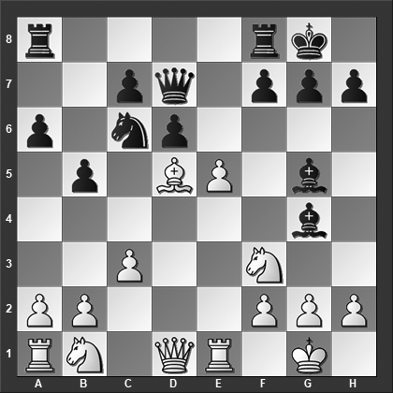

*How should White best continue?*

**14.h3!!** This just wins. Rather surprisingly, the young Capablanca missed it: 14.Nxg5?? Bxd1 15.e6 fxe6?? (15...Qd8! wins) 16.Bxe6+ Qxe6 17.Nxe6 Rae8 18.Nd2 Rf6 19.Raxd1 Rfxe6 with equal chances in the endgame, Capablanca-Lasker, London 1913. After 14.h3 Black loses material, e.g., 14...Bxf3 (or 14...Bh5 15.e6! Bxf3 16.gxf3) 15.Qxf3 Nxe5 16.Rxe5 dxe5 17.Bxa8 and White is a piece. Therefore, after 14.h3, Black resigned.

**1–0**

# **From Chapter 7**

# **Petroff / Russian Game**

**Game # 115**

**E.Vorobiov (2552) – A.Gusev (2404) C42**

Tula 2004

**1.e4 e5 2.Nf3 Nf6 3.Nxe5 Qe7?!**

This is not an outright error, but it does take the safety out of the Petroff for Black without getting anything tangible in return...

**4.d4 Nc6 5.Nf3 Qxe4+ 6.Be2 Nb4?**

6...d5 7.0–0 Bd6 8.Nc3 (8.Re1 0–0 9.Nc3 Qf5 10.Bd3 Qh5 is more or less okay for Black) 8...Qe7 9.Re1 Be6 10.Bb5 and White has the somewhat better chances.

**7.Na3 Nbd5??**

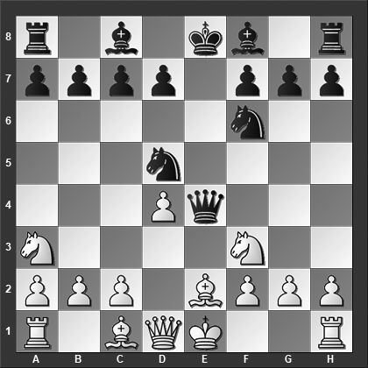

*Black doesn't have time for this kind of goofing around; he sets up the simple threat 8...Bxa3 9.bxa3 Nc3. Can you find the best response for White?*

Black should have played 7...d5 8.0–0 Bd6 9.Bb5+ Kf8 which nevertheless obviously is better for White.

**8.0–0!**

Anyway! Due to Black's king and queen being placed on the open e-file White can take some liberties.

**8...Bxa3 9.Bd3! Qg4 10.h3 Qh5 11.Re1+ Be7**

Did White miss something?

**12.Re5!** Nope! This is the point, Black's queen is trapped and he resigned.

After 12.Re5 g5 13.Rxg5 Qh6 14.Rxd5 Qf8 15.Re5 Black is completely busted.

**1–0**

# **From Chapter 8**

# **Philidor’s Defense**

**Game # 133**

**O.Rodriguez Vargas (2435) – J.Emma (2385) C41**

Buenos Aires 1973

**1.e4 e5 2.Nf3 d6 3.d4 Nf6 4.dxe5 Nxe4 5.Bc4 c6 6.Nbd2**

White can also consider 6.0–0 d5, and here:

7.Bb3 Be7 8.c4 dxc4 9.Qxd8+ Bxd8 10.Bxc4 Nc5 11.Be3 Be6 12.Nbd2 Be7 13.Nd4 Bxc4 14.Nxc4 and White has the initiative in the queenless middlegame, Noritsyn-Sambuev, Montreal 2017.

7.Bd3 Nc5 8.Be2 Be7 9.Be3 0–0 10.c4 dxc4 11.Bxc4 Be6 12.Bxe6 Nxe6 13.Nc3 was played in Xu Yuhua-Jobava, Doha 2016, and now 13...Nd7 14.Rc1 Ndc5 would have been about equal.

**6...Nxd2**

It seems safest to exchange the knight, for instance, 6...Nc5 7.exd6 Bxd6 8.0–0 0–0 9.b4 Nca6 10.Ne4 Be7 was Sanal-Novoselski, Albena 2014, 11.a3 Nc7 12.Qe2 Be6 13.Bb2 a5 14.Rfd1 and White has the clearly better chances.

**7.Bxd2 d5 8.Bd3 Nd7**

8...Be7 9.Qe2 Na6 10.c3 Nc5 11.Bc2 Bg4 12.h3 Bh5 13.Be3 Bg6 14.Bxc5 Bxc5 15.0–0–0 Bxc2 16.Qxc2 Qe7 is pretty much even, L.B.Hansen-S.Pedersen, Odense 1994.

**9.b4 g6**

9...a5!?

**10.Qe2 Qe7 11.0–0 Bg7 12.Bg5 f6 13.exf6 Bxf6??**

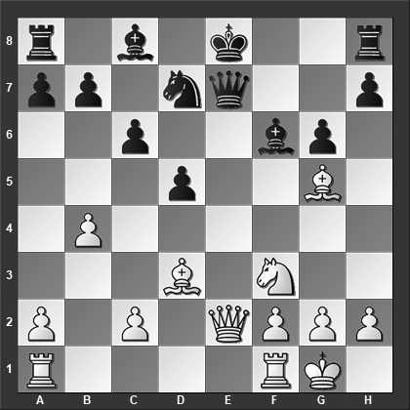

*Why is this a big mistake?*

The alternative is 13...Nxf6 14.Rae1 Qxe2 15.Rxe2+ Kf7 16.Rfe1 Rf8 17.Re7+ Kg8 18.Ne5 with a small but clear advantage for White.

**14.Rae1!** And now, somewhat prematurely, Black resigned. After 14.Rae1 Qxe2 15.Rxe2+ Kd8 16.Rfe1 (Now the threat is 17.Nd4!) 16...a5 (or 16...h6 17.Bxf6+ Nxf6 18.Ne5) 17.b5 Rg8 18.Re6 with a large advantage for White although this is hardly a reason for Black to resign.

**1–0**

# **From Chapter 9**

# **King’s Gambit**

**Game # 148**

**A.Fedorov (2600) – P.H.Nielsen (2515) C35**

Aaland-Stockholm 1997

**1.e4 e5 2.f4 exf4 3.Nf3 Be7 4.Bc4 Bh4+ 5.Kf1 d5 6.exd5 Bg4 7.d4**

Or 7.Qe2+?! Ne7 8.Qe4 Bxf3 9.Qxf3 Ng6 10.d4 Qf6 11.c3 0–0 12.g3 fxg3 13.Qxf6 Bxf6 14.hxg3 Nd7 with chances to both sides, Jonkman-Mitkov, Cappelle-la-Grande 1994.

**7...Ne7 8.Nc3**

White has also tried 8.Qd3 Bf6 9.Bxf4 0–0 10.Nc3 c6 (10...Nd7!?) 11.d6 Bf5 12.Qd2 Nc8 13.Re1 Nxd6 14.Bb3 Bg4 15.Bxd6 Qxd6 16.Ne4 Qd8 17.Qf4 and White has a large advantage, Pruess-Sevillano, San Francisco 2004.

**8...Ng6 9.Qe2+ Be7 10.h4!?**

Or 10.Qe4 0–0 (10...Nd7!?) 11.Ne5 Bh5 12.Qf5 Nxe5 13.dxe5 Bg6 14.Qxf4 Bxc2 15.Be3 Nd7 16.Rc1 Bg6 17.h4 and White has the better position, Ludwikow-Wedberg, Stockholm 1990.

**10...h5 11.Qe4 Nd7?**

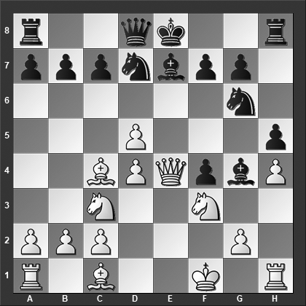

*How should White best continue?*

Black should have played 11...0–0 12.Ne5 Nxe5 13.dxe5 when White has somewhat better chances.

**12.d6!**

12.Bxf4? Nf6 13.Qe3 0–0 14.Re1 Bf5 15.Ne5 Ng4 16.Nxg4 Bxg4 was okay for Black in Maes-Mitkov, Cappelle-la-Grande 1994.

**12...cxd6 13.Ng5!** Black resigned. He has no adequate way of protecting the f7 pawn.

**1–0**

# **From Chapter 10**

# **Vienna Game & Bishop’s Opening**

**Game # 155**

**I.Hausner (2445) – Z.Szymczak (2400) C24**

Prague 1989

**1.e4 e5 2.Bc4 Nf6 3.d4 exd4 4.Nf3 Nxe4 5.Qxd4 Nf6 6.Bg5 Be7 7.Nc3 0–0 8.0–0–0 h6**

Black can also consider 8...c6 9.Rhe1 d5, and now: 10.Qh4 (10.Bd3 a5 11.Qh4 h6 12.Bxh6 Ne4 13.Qh5 g6 14.Qe5 Bf6 15.Qf4 Nxc3 16.Bxf8 Nxd1 17.Bh6 Bxb2+ 18.Kxd1 Nd7 19.Ng5 Bf6 20.h4 Nf8 21.h5 Bd7 22.Re5 and now the game is scored as a win for White in my database, Allerberger-Paleckis, Remote email 2011. This seems premature, but Black is basically without any useful moves.) 10...h6? (10...Bf5!?) 11.Bxd5! cxd5 12.Nxd5 hxg5 13.Nxg5 Qxd5 14.Rxd5 Nc6 was played in Sebastianelli-Naumkin, Porto San Giorgo 2003, and now 15.Rd3 Bg4 16.Rg3 Bh5 17.Rh3 would crash through for White.

**9.Qh4 d6**

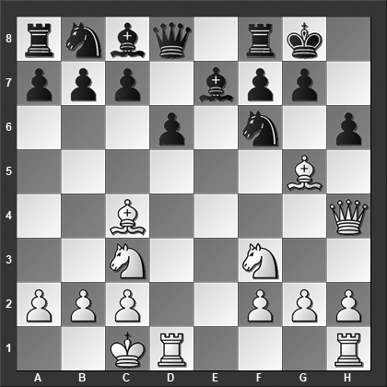

*How should White continue?*

Black should accept the piece on g5, e.g., 9...hxg5 10.Nxg5 d6 11.Bd3 Re8 12.Bh7+ and here a draw was agreed upon, ½–½, De Visser-Semenov, ICCF email 2013.

**10.Bxh6! gxh6 11.Qxh6 Nh7**

Black's best appears to be something like 11...c6 12.Rhe1 Nh7 13.Re5! and White is winning.

**12.h4**

White can play even more forcefully with 12.Rd5! Bf6 13.Rh5 and Black is busted.

**12...Nc6?! 13.Bd3 f5 14.Bc4+ Kh8 15.Ng5** and Black resigned before he would get mated.

**1–0**

# **From Chapter 11**

# **Minor Openings**

**Game # 172**

**M.Todorcevic (2535) – V.Kovacevic (2545) C44**

Ljubljana/Portoroz 1989

**1.e4 Nf6 2.d3 d5 3.Nd2 e5 4.Ngf3 Nc6**

Now we are back in the Open Games. The move order could also have been 1 e4 e5 2 Nf3 Nc6 3 d3 Nf6 4 Nbd2 d5, which is why this game is classified the way it is.

**5.g3 Bc5**

Another common move is 5...Be7, and here 6.Bg2 0–0 7.0–0 Re8 8.c3 a5 9.exd5 Nxd5 10.Re1 f6 (10...Bf8!?) 11.Nc4 (11.d4!?) 11...Be6 12.Ne3 Bf8 13.d4 exd4 14.Nxd4 was tested and promised White the somewhat better chances in Svidler-Wang Hao, Dubai 2014.

**6.Bg2**

Or 6.h3 dxe4 7.dxe4 b6 8.Bb5 Bd7 9.Qe2 0–0 10.c3 a5 11.Kf1 Qe8 12.Kg2 Nd4 13.Bxd7 Nxe2 14.Bxe8 Rfxe8 15.Re1 Nxc1 16.Raxc1 with even chances in Claverie-Zarnicki, Buenos Aires 2002.

**6...dxe4**

A major alternative is 6...0–0, and now White can consider:

7.exd5 Nxd5 8.0–0 Nf6 9.a3 a5 10.Nc4 Re8 11.Be3 Bxe3 12.Nxe3 Be6 13.Ng5 Bd7 14.c3 h6 15.Ne4 Nxe4 16.Bxe4 with more or less even chances, although I personally would prefer to play white, Plomp-Toro Solis de Ovando, Argentina 2001.

7.0–0 Re8 8.c3 a5 9.Qc2 (9.exd5!?) 9...Ba7 10.b3 h6 (10...d4!? 11.c4 Bc5 leads to an entirely different type of position that seems comfortable for Black) 11.Bb2 Be6 12.a3 Qd7 13.exd5 Bxd5 14.c4 Bxf3 15.Nxf3 Rad8 16.Rad1 Nd4 (16...Qd6!? to not release the tension quite so quickly seems like a better move) 17.Nxd4 Bxd4 18.Bxd4 exd4 and the chances are approximately equal, Bokros-Roubalik, Slovakia 2016.

**7.dxe4 0–0 8.0–0**

8.Qe2?! looks natural but it actually hands the initiative to Black: 8...a5 9.0–0 b6!? (taking advantage of the placement of White's queen to grab the initiative) 10.Nb3 Ba6 11.c4 (forced by the circumstances but not typically a move White wants to play) 11...Be7 12.Bg5 Qc8 13.Nbd2 h6 14.Bxf6 Bxf6 and Black already has a very comfortable position, Gonzalez Zamora-Barua, Balaguer 1997.

**8...a5 9.a4 Qe7 10.c3 Rd8 11.Nh4**

A rather ambitious plan, White wants to play Nf5, encouraging Black to exchange it with the bishop, and then the bishop on g2 comes to full flourish. An idea that is seen regularly in the Reti Opening and the King's Indian Attack. 11.Qe2 b6 12.Nc4 Ba6 is also better for Black.

**11...g6**

Black is not interested in letting White play Nf5 and puts an immediate stop to those ideas.

**12.h3?**

This move is not only unnecessary, but it also weakens White's kingside pawn shield considerably as we will see in the game. Instead 12.Qe2 b6 13.Nc4 Qe6 14.b3 Ba6 would have been a somewhat better choice although Black clearly is the party with the better chances in this position.

**12...b6 13.Re1?**

After this move, White's position rapidly disintegrates. The alternatives are not pretty either, for instance, 13.Qe2 Ba6 14.Nc4 Nh5 (threatening ...Nxg3) 15.Kh2 Nf4! 16.Bxf4 exf4 17.e5 Bxc4 18.Qxc4 fxg3+ 19.fxg3 Nxe5 and White has lost a pawn with no compensation to show for it.

**13...Rd3!**

Threatening ...Rxg3.

**14.Nhf3**

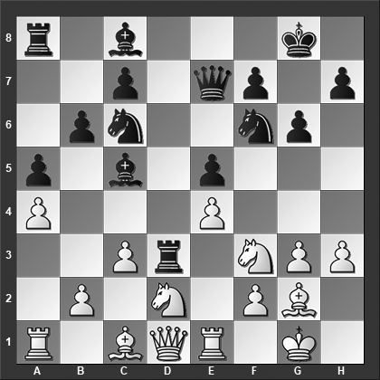

*How should Black best continue?*

**14...Bxf2+! 15.Kxf2 Qc5+** White resigned. After 16.Kf1, Black plays 16...Nh5 ending the party quickly, .e.g., 17.Re2 Nxg3+ 18.Ke1 Nxe2 19.Qxe2 Re3 and White can resign.

**0–1**

# **From Chapter 12**

# **Minor Gambits**

**Game # 183**

**J.Mieses – J.Taubenhaus C44**

Ostend 1906

**1.e4 e5 2.d4 exd4 3.c3 d5 4.exd5 Qxd5 5.cxd4 Nc6 6.Nf3 Bg4 7.Be2 0–0–0 8.Nc3 Qh5 9.a3**

The main lines are 9.Be3 and 9.0–0.

**9...Bd6 10.Be3 Nf6 11.Rc1 Rhe8 12.Nb5 Nd5**

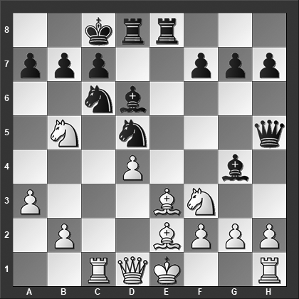

*What is White's best move?*

Black should play 12...Bxf3 13.Nxd6+ Rxd6 14.Bxf3 Qa5+ with a good game.

**13.Rxc6!**

A year prior, in a game between the same players, Mieses played 13.Nxd6+ Rxd6 14.Qd2 Rde6 and Black was already clearly better, Mieses-Leonhardt, London 1905.

**13...bxc6 14.Nxa7+ Kd7?**

To stay in the game, Black had to play 14...Kb8 but 15.Nxc6+ Kc8 16.Qb3 Nxe3 17.fxe3 Kd7 18.h3 should win for White.

**15.Ne5+** Black resigned.

**1–0**