# 

# **From Chapter 1**

# **Scandinavian Defense – The Center Counter**

**Game # 6**

**S.Vajda (2285) – A.Skripchenko (2370) B01**

World Ch U20 Girls (Medellin) 1996

**1.e4 d5 2.exd5 Qxd5 3.Nc3 Qa5 4.d4 Nf6 5.Bd2 c6 6.Bc4 Bf5 7.Qf3 e6**

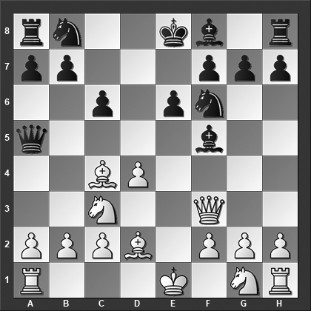

*What is the most dangerous move for Black to meet?*

Two other options for Black are:

7...Bxc2 8.d5?! (White appears able to improve with 8.Nd5 Qd8 9.Nxf6+ gxf6 10.Rc1 Bg6 11.Ne2 Nd7 12.h4 with excellent compensation for the pawn) 8...Qc5 9.b3 Nbd7 10.dxc6 bxc6 11.Qe2 Qe5 12.Rc1 Bg6 13.Nf3 Qxe2+ 14.Bxe2 e6 and White has just about sufficient compensation for the sacrificed pawn, Maryasin-Bocharov, Novosibirsk 2015.

7...Bg4?! 8.Qf4 Qf5 9.Qe3 b5 10.Bb3 b4 11.Nce2 Bxe2 12.Nxe2 e6 13.Ng3 Qb5 14.c4 bxc3 15.bxc3 and White is clearly better, Hector-Westerinen, Reykjavik 1997.

**8.d5!**

White can also play 8.Nd5 and 8.Ne4, but neither move challenges Black too much. The text move is far trickier to face.

**8...Bg4**

The alternatives are:

8...Bb4 9.dxe6 Bxe6 10.Bxe6 fxe6 11.Qe2 0–0 12.Nf3 Re8 13.0–0 Qa6 14.Rfe1 Qxe2 15.Rxe2 with a positional advantage for White, S.Vajda-Podinic, Bucharest 2001.

8...Qc5?! 9.dxe6 Bxe6 (9...fxe6 is marginally better but not by much) 10.Bxe6 Qe5+?! 11.Kf1 fxe6 12.Re1 Qd4? 13.Rxe6+ Kf7 14.Qe2 Nbd7 15.Nf3 Black is completely busted, the end came quickly... 15...Qg4 16.h3 Qf5 17.g4 Qxc2 18.Ng5+ Kg8 19.Rxf6 and Black resigned, 1–0, Repkova-Trtanj, Rijeka 2003.

8...Be7 9.dxe6 Qe5+ 10.Qe2 Qxe2+ 11.Ngxe2 Bxe6 12.Bxe6 fxe6 13.0–0–0 Nbd7 14.f3 Kf7 15.Rhe1 Rhe8 16.Nf4 with a small positional plus for White, Chernov-Arbinger, Davos 2005.

**9.Qf4 cxd5?**

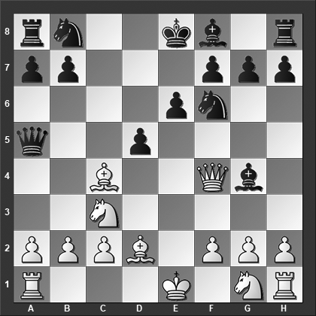

*How should White best continue?*

This loses. Instead, 9...Bb4 10.dxe6 (10.a3 exd5 11.Ba2 Be7 12.Ne4 Qb5 13.Nxf6+ Bxf6 14.Qxg4 Qxb2 15.Rd1 Nd7 (15...Qxa2?? 16.Qc8+ Bd8 17.Qxb7 loses) 16.Qe2+ Be7 17.Bb1 and Black has some but not full compensation for the piece) 10...fxe6 11.f3 Bf5 12.Nge2 Nd5 13.Bxd5 cxd5 14.a3 Nc6 15.Nd4 Nxd4 16.Qxd4 Bxc3 17.Bxc3 Qc7 18.0–0–0 0–0 and White has the better chances, Spiess-Schwarzmeier, Bayern 2006.

**10.Bb5+!**

The alternatives are less impressive: 10.Nb5? Bb4 11.c3 dxc4 12.Nc7+ Kd7 13.Nxa8 Bd6 14.Qxc4 Nc6 15.f3 Bf5 16.Qb3 Qa6 17.Ne2 Rxa8 18.0–0–0 Na5 19.Qa4+ b5 and White resigned, 0–1, Grove-Lindestrom, Esbjerg 2007.

10.Ne4? Qb6 11.Nxf6+ gxf6 12.Qxf6 Rg8 13.Bb3 Nc6 and White is already in serious trouble, Nygren-Persson, Sweden 1999; 10.Nxd5!? Nxd5 11.Qxg4 Qc5 with just a small plus for White.

**10...Kd8**

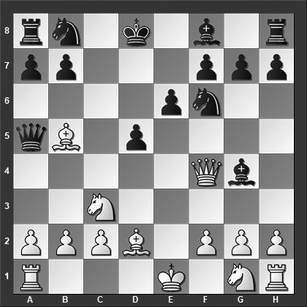

*What is White's best move?*

Or 10...Nc6 11.Bxc6+ bxc6 12.Ne4 Qb6 13.Nxf6+ gxf6 14.Qxg4 Qxb2 15.Rc1 and White is a piece up.

**11.Nxd5!** Black resigned.

**1–0**

# **From Chapter 2**

# **Pirc Defense**

**Game # 33**

**Y.Yakovich (2565) – A.Gual Pascual (2420) B07**

Terrassa 1999

**1.e4 d6 2.d4 Nf6 3.Nc3 g6 4.Bg5 Nbd7 5.f4 c5?!**

The most popular move for Black is 5...h6 but I doubt it is best, we will cover it in the next main game below.

5...c6 is the most solid option for Black: 6.Qf3 (White can consider 6.Nf3 Bg7 7.e5 dxe5 8.fxe5 with better chances for White) 6...Qa5 7.a3 d5 8.e5 Ne4 9.Bh4 Nxc3 10.Qxc3 Qxc3+ 11.bxc3 Bh6 12.Ne2 Nb6 and Black has a pleasant position, Rozman-Popilski, Dallas 2016.

**6.e5 dxe5**

The alternatives are:

6...h6 7.Bh4 Nh5 (7...Nh7?? 8.exd6 Nhf6 9.dxc5 Nxc5 10.Bb5+ Bd7 11.Bxf6 exf6 12.Qe2+ Ne6 13.0–0–0 Qa5 14.f5 gxf5 15.Bxd7+ Kxd7 16.Qh5 and Black is busted, Arias Santana-Yip, Saint Louis 2017) 8.exd6 Nxf4 9.Nge2 Ne6 10.d5 Ng5 11.dxe7 Bxe7 12.Bg3 0–0 13.h4 Nh7 14.Qd2 h5 15.0–0–0 and White has the upper hand, Ljubicic-Berebora, Split 1998.

6...Nh5 7.g4 cxd4 8.Qxd4 dxe5 9.fxe5 Ng7 10.e6 Nxe6 11.Qxh8 Nxg5 12.0–0–0 and White is much better and soon won, Vasiukov-Pribyl, Zalaegerszeg 1977.

**7.dxe5 Nh5 8.Bc4 h6 9.e6 fxe6 10.Qd3 Kf7?**

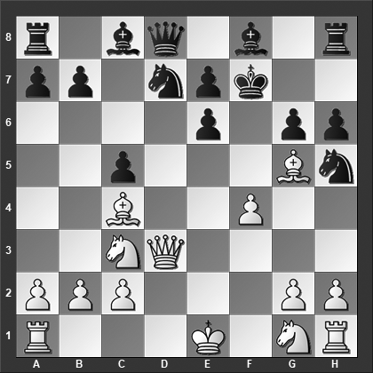

*How should White continue his attack?*

Black should have played 10...Qb6 11.g4 (11.Qxg6+ Kd8 12.0–0–0 hxg5 13.fxg5 Bg7 is fine for Black) 11...hxg5 12.gxh5 Qd6 13.Qxg6+ Kd8 14.fxg5 Qf4 15.Qe4 is better for White.

**11.Nf3!**

This is devastating for Black. The threat of Ne5+ forces Black to attempt a hopeless defense...

**11...Ng7**

Protecting the pawn on e6.

**12.0–0!**

White improves on his position quietly as Black cannot mobilize any kind of defense, let alone counterplay. Note that White has only sacrificed a pawn to make this happen.

**12...Qb6 13.Nh4** Black resigned. After 13.Nh4 Nf5 14.Nxf5 gxf5 15.Rae1 Nf6 16.Qxf5, Black's position collapses entirely.

**1–0**

# **From Chapter 3**

# **Modern Defense**

**Game # 55**

**I.Khenkin (2575) – G.Schebler (2365) B07**

Eupen 1993

**1.d4 d6 2.e4 Nf6 3.Nc3 c6 4.f4 Qa5 5.Bd3 Bg4 6.Qd2 e6?**

Not a good idea as we will soon see demonstrated in the game. Black has tried a bunch of different other moves at this juncture:

6...Bc8 7.Nf3 Nbd7 8.0–0 e5 9.Kh1 Be7 10.Qe1 Nh5 11.fxe5 dxe5 12.Bd2 Qc7 was Piorun-R.Schmidt, Bucharest 2010, and now 13.Be2! Nhf6 14.dxe5 Ng4 15.Qg3 Nf8 16.Bc4 would have been truly horrible for Black.

6...g6 7.h3 Bd7 8.Nf3 Na6 9.0–0 Nh5 10.Qf2 Nb4 11.Bc4 d5 12.Bb3 e6 13.Ne5 f5 14.exf5 exf5 15.Bd2 Qc7 , Yakovich-Abdelnabbi, Dubai 2001, and here 16.Na4 Na6 17.c4 would bust Black.

6...d5?! 7.e5 Ne4?? 8.Nxe4 Oops! Black resigned, 1–0, Wang Puchen-S.Schmid, Zalakaros 2008.

6...Bd7 7.Nf3 (7.e5!?) 7...g6 8.0–0 Bg7 9.Nd5 Qxd2 10.Nxf6+ Bxf6 11.Bxd2 Bg4 12.Be3 Bxf3 13.Rxf3 Nd7 14.c3 with somewhat better chances for White, Filipenko-Gofshtein, Belgorod 1989.

6...e5 7.dxe5 dxe5 8.f5 Bc5 9.h3 Bh5 10.g4 Bxg4 11.hxg4 Nxg4 12.Qg5 Nf2 13.Qxg7 Rf8 14.Rxh7 (Black could have played 14.Qxe5+ Kd8 15.Qf6+ Ke8 16.Rxh7 with an even greater advantage) 14...Nd7 15.Rh8 0–0–0 16.Rxf8 Rxf8 17.Nf3 Qd8 was Raisa-Dunworth, Espoo 1991, and now 18.Bc4 is just horrible for Black; the knight on f2 doesn't have a way home and Black is just down a piece.

**7.h3 Qh5 8.Qf2 d5 9.e5 Nfd7**

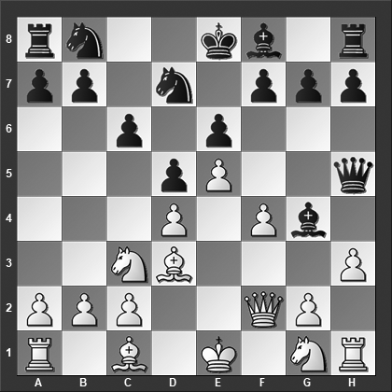

*What is White's best move?*

Here Black should have swallowed his pride and dropped a pawn to save his pieces with 9...Ne4 10.Nxe4 dxe4 11.Bxe4 Be7 12.Ne2 Bxe2 13.Qxe2 Bh4+ 14.Kd1 Qxe2+ 15.Kxe2 and White has the extra pawn and the bishop pair.

**10.Rh2!!**

This clever move highlights all the problems for Black. Of course, 10.Nge2 is also a decent continuation but nowhere near as dangerous for Black, e.g., 10...Bxe2 11.Nxe2 f5 12.g4 Qf7 (however, not 12...fxg4 on account of 13.f5 exf5 14.e6 Nb6 15.Ng3 Qg6 16.Bxf5 and White is winning) 13.gxf5 exf5 14.Ng3 g6 15.h4 h5 16.Bd2 with a clear advantage.

**10...Be7**

The point behind the previous move is that 10...Bf5 now can be answered with 11.g4 when the queen protects the rook.

**11.f5! Bxf5 12.g4**

The point behind the previous move. Now White wins a piece for some pawns and the black queen is still in peril.

**12...Bxg4 13.hxg4 Qxg4 14.Rg2 Qh5 15.Be2** Black resigned.

**1–0**

# **From Chapter 4**

# **King’s Fianchetto – 1…g6**

**Game # 61**

**R.Skytte (2323) – R.Felgaer (2390) B06**

World Ch U20 (Yerevan) 2000

**1.e4 c5 2.Nc3 g6 3.d4 Bg7 4.dxc5 Qa5 5.Bd2 Qxc5 6.Nd5**

I'm not sure why anybody would want to enter this line as Black because it to spell nothing but trouble for Black.

**6...Na6 7.Nf3 e6 8.Bc3 Bxc3+ 9.Nxc3 Nf6**

Black has some alternatives at this juncture, that being said, the theoretical verdict is clearly favoring White:

9...Ne7 10.Qd2 Nc7 11.e5 f5 12.exf6 Ned5 13.Ne4 Qb4 14.Qxb4 Nxb4 15.Nd6+ Kf8 16.0–0–0 Ne8 17.Nxc8 Rxc8 18.Rxd7 Rxc2+ 19.Kb1 with a large advantage for White, Petrisor-Simacek, Legnica 2013.

9...Nc7 10.Qd2 b5 11.e5 Bb7 12.0–0–0 Bxf3 13.gxf3 Qxe5 14.f4 Qc5 15.Qxd7+ Kf8 16.Ne4 Qe7 17.Qc6 and White is winning, Ragger-Supancic, Austria 2005.

**10.Qd2**

White can also consider:

10.e5 Ng4 11.Qe2 d6? (11...f6 12.Ne4 Qa5+ 13.c3 is relatively better but still unpleasant for Black) 12.0–0–0 Nxf2 13.Na4 Qa5 14.Qxf2 Qxa4 15.exd6 0–0 16.Kb1 Bd7 17.Ne5 Rad8 was played in Oleksienko-Shkuran, Ternopil 2003, and here 18.Bxa6 Qxa6 19.Qf6 is completely game over for Black; the main threat is Nxf7 along with h2–h4.

10.Bd3?! is too tame, e.g., 10...d6 11.0–0 0–0 12.Qd2 Kg7 13.e5 dxe5 14.Qg5 h6 15.Qxe5 Qxe5 16.Nxe5 Nc5 and Black has equalized, Moiseenko-Solovjov, Peterhof 2008.

**10...d6?**

Or 10...0–0 11.0–0–0 (White can even improve with 11.e5! Ng4 12.Bxa6 bxa6 13.Ne4 Qb6 14.0–0 with a dreadful position for Black) 11...Ng4 12.Bxa6 bxa6 13.Rhf1 f6 14.Qd6 Qxd6 15.Rxd6 Kf7 16.h3 Ke7 17.Rd2 Ne5 18.Nxe5 fxe5 19.Rfd1 with a small but obvious positional advantage for White, Barle-Forintos, Maribor 1977.

**11.0–0–0 Ke7**

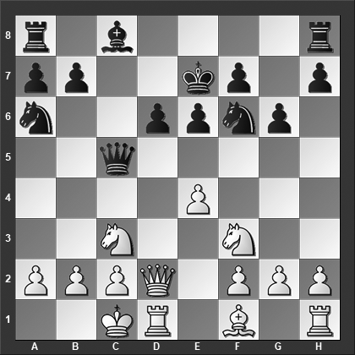

*How should White best continue?*

Also 11...0–0 12.Qxd6 Qxf2? 13.Qf4 Kg7 14.Bxa6 bxa6 15.Qe5 Qb6 16.Rhf1 Qb8

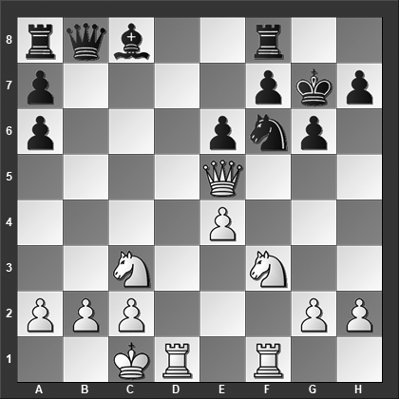

*is a disaster for Black; this was played in Ponkratov-Pridorozhni, Khanty-Mansiysk 2013, where White now missed the best move, can you do better?*

17.Rd6! Kg8 18.Qxf6! Qxd6 19.Nd5! Re8 20.Ng5 Qf8 21.Nxf7 Qg7 22.Nd6 and it is completely curtains for Black.

**12.Bxa6! bxa6 13.e5! Nd7**

After 13...dxe5 the point behind White's sequence of moves emerges: threatening Ne4, and after 14.Qg5! Qc4 (or 14...h6 15.Qxf6+ Kxf6 16.Ne4+ and White has won a piece) 15.Nxe5 and Black has no defense.

**14.Ne4 Qc4** and Black resigned at the same time. After 15.Qxd6+ Kd8 16.Nfg5 Rf8 17.Nc5 it is completely game over for Black.

**1–0**

# **From Chapter 5**

# **Alekhine Defense**

**Game # 99**

**M.Apicella (2506) – J.De la Villa Garcia (2458) B04**

Montpellier 2000

**1.e4 Nf6 2.e5 Nd5 3.d4 d6 4.Nf3 g6 5.Be2 Bg7 6.h3 dxe5 7.Nxe5 c5**

7...0–0 8.0–0 c5 9.Bf3 cxd4 10.Qxd4 Be6 11.Rd1 Qc7 12.Bxd5 Bxe5 13.Qa4 Rd8 14.c4 Bxd5 15.cxd5 Nd7 and Black had a comfortable game, Pietrusiak-Hort, Halle 1967.

**8.Bb5+ Nd7 9.0–0 cxd4 10.Qxd4**

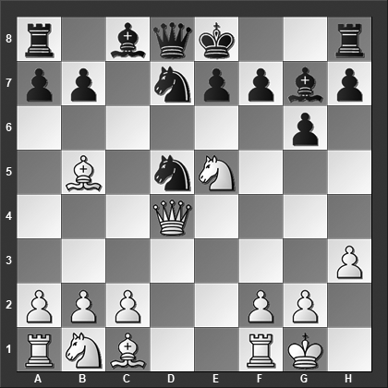

*How should Black best continue?*

**10...Nc7**

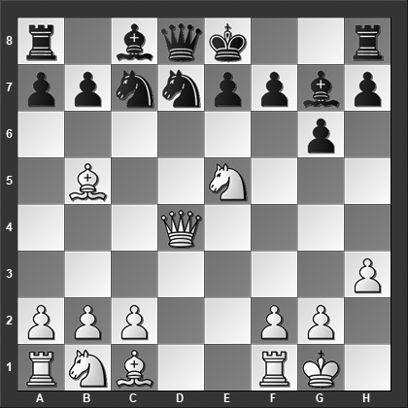

*How should White meet this move?*

With 10...0–0! 11.Qxd5 Nxe5 12.Nc3 Qc7 13.Rd1 a6 Black could have equalized.

**11.Nxd7! Bxd4**

Or 11...Nxb5 12.Qxg7 Kxd7 13.Rd1+ Nd6 14.Nc3 Qf8 15.Qd4 when Black is still technically alive, but his position is a disaster.

**12.Nf6+** Black resigned. After 12...Kf8, 13.Bh6 mates.

**1–0**

# **From Chapter 6**

# **1…Nc6, 1…b6 & 1…a6**

**Game # 104**

**V.Kachar (2390) – I.Odesskij (2425) B00**

Moscow Ch 1999

**1.d4 b6 2.e4 e6 3.Nf3 Bb7 4.Bd3 c5 5.d5 exd5 6.exd5 Bxd5 7.0–0**

The more forcing 7.Nc3 is also possible when Black has to decide what to do about his bishop on d5. Now:

7...Be6 8.Bf4 a6 9.Qe2 (9.Be4!?) 9...Nf6 10.0–0–0?! (10.Rd1!?) 10...Be7 11.Rhe1 b5 12.Ng5 Qb6 13.Bf5 0–0 14.Qd3 h6 15.Bxe6 dxe6 16.Nge4 Nbd7 and White definitely doesn't have enough for the pawn, James-Shaw, Liverpool 2008.

7...Bc6 8.0–0 (or 8.Qe2+ Be7 9.0–0 Nf6 10.Re1 Bxf3 11.Qxf3 Nc6 12.Bg5 Kf8 13.Rxe7 Nxe7 as played in Rossi-Lucaroni, Filettino 1994, when 14.Ne4 Nxe4 15.Bxe4 Rb8 16.Rd1 would have provided White excellent compensation for the exchange) 8...Nf6 9.Bg5 Be7 10.Bxf6 Bxf6 11.Re1+ Kf8 12.Bc4 g6 13.Qd6+ Kg7 14.Nd5 b5 15.Bd3 c4 16.Bf1 , Stajner-Kovacevic, Slovenia 2005, and now 16...Bxd5 17.Qxd5 Nc6 18.Qxb5 Rb8 19.Qxc4 Rxb2 would have led to approximately equal chances.

**7...Nf6**

Or 7...Nc6 8.Nc3 Be6 9.Bf4 Nf6 10.Nb5 d6 11.Re1 a6 12.Nc3 Be7 13.Ng5 Qd7 as in Martorelli-Dragojlovic, Castellaneta 2000, and now 14.Nce4 Nd5 15.Bg3 would have left White with good compensation for the pawn.

**8.c4**

Another try is 8.Nc3 Bb7 9.Re1+ Be7 10.Nh4 0–0 11.Nf5 Re8 12.Bg5 Nc6 13.Qf3 and Black is completely busted, Aguera Naredo-Redondo Benavente, Linares 2015, for instance 13...h6 14.Bh4 Kf8 15.Nb5 a6 16.Bxf6 Bxf6 17.Nbd6 and it is obvious that Black is in dire straits.

**8...Bb7 9.Nh4 Be7 10.Nf5! 0–0 11.Re1 Re8 12.Bg5 Na6**

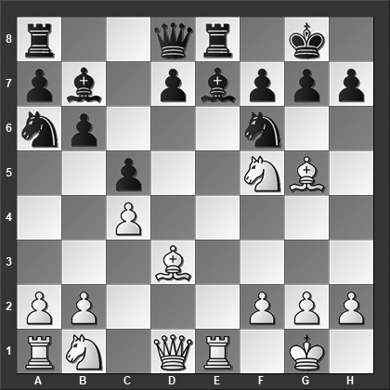

*White has the initiative; how should he best continue?*

Or 12...h6 13.Nxe7+ Rxe7 14.Bxf6 Rxe1+ 15.Qxe1 gxf6 (15...Qxf6?? 16.Qe8#) 16.Qe3 and White has a very clear advantage.

**13.Rxe7!** Black resigned. After 13…Rxe7 14.Bxf6 gxf6 15.Qg4+ it is over.

**1–0**