# 

# **From Chapter 1**

# **Najdorf Variation**

**Game # 14**

**J.Timman (2480) – L.Polugaevsky (2645) B96**

Hilversum 1973

**1 e4 c5 2 Nf3 d6 3 d4 cxd4 4 Nxd4 Nf6 5 Nc3 a6 6 Bg5 e6 7 f4 Nbd7 8 Qf3 Qc7 9 0–0–0 b5 10 Bd3 Bb7 11 Rhe1 h6!?**

This is an interesting choice that is still relatively unexplored.

**12 Qh3**

12 Bh4 Be7 13 Nd5 (13 Qe2?! was played in D.Minic-M.Milicevic, Yugoslavia 1975, but Black should just be doing very well after 13...b4 14 Nb1 Nc5, and only Black can be better) 13...Nxd5?! (Black can take the piece: 13...exd5! 14 Nf5 Kf8! is better for Black) 14 exd5 Bxh4 15 Nxe6 fxe6 16 Qh5+ Kd8 17 Qxh4+ Nf6 18 dxe6 Re8 19 g4 Qc5 20 Qg3 Rc8, and White has some, but possibly not full compensation for the sacrifices piece, E.Geller-L.Polugaevsky, Kislovodsk 1972.

**12...0–0–0 13 Bxf6**

The only real alternative for White is 13 f5 which should not cause Black too many headaches after 13...e5! 14 Nb3 (14 Ne6? hxg5! 15 Qxh8 fxe6 16 fxe6 Nc5 17 Qh3 g4, and Black is winning, B.Spassky-J.Donner, Amsterdam 1973) 14...Be7 15 Bxf6 Nxf6 16 a4 bxa4 17 Nxa4 Kb8 18 Qg3 d5 19 exd5 Nxd5 20 Kb1 Nf4, and Black has taken over the initiative, Liu Qingnan-Zhou Jianchao, Xinghua 2014.

**13...Nxf6**

If Black recaptures with the pawn, 13...gxf6 White obtains an advantage with 14 f5 e5 15 Ne6! fxe6 16 fxe6 Kb8 17 exd7, and White has the better chances on account of the weak light squares in Black's position.

**14 Nd5?!**

White can also consider 14 a4 bxa4 15 Nxa4 Kb8 with more or less even chances.

**14...Qa5**

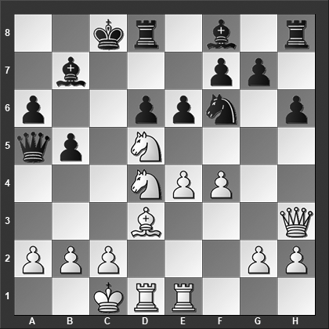

*Black decides to leave the knight be on d5. How should White now continue?*

Black should have opted for 14...Nxd5 15 exd5 Bxd5, and now 16 a4 Qb6 17 axb5 Qxd4 18 Be4 Qxe4 (Black probably avoided 18...Qa4 because after 19 Rxd5 Qa1+ 20 Kd2 Qa5+ 21 b4 Qxb4+ 22 c3 Qa3 23 Rb1 White is doing rather well) 19 Rxe4 Bxe4 20 bxa6 Kd7 21 Rd4 Bc6 22 b4 Be7 23 Qb3 Rb8 24 c4 Rhc8 25 Kd1 d5 with a complicated endgame-like position that eventually ended in a draw, but at this point, it could have gone either way, A.Kosteniuk-S.Karjakin, Wijk aan Zee 2003.

**15 Nb3!** And Black resigned; after 15…Qxa2 16 Nc3, the queen is trapped.

**1–0**

# **From Chapter 2**

# **Scheveningen Variation**

**Game # 36**

**A.Beliavsky – A.Vitolinsh B86**

Soviet Ch semifinal (Riga) 1972

**1.e4 c5 2.Nf3 d6 3.d4 cxd4 4.Nxd4 Nf6 5.Nc3 a6 6.Bc4 e6 7.0–0 Be7 8.a3**

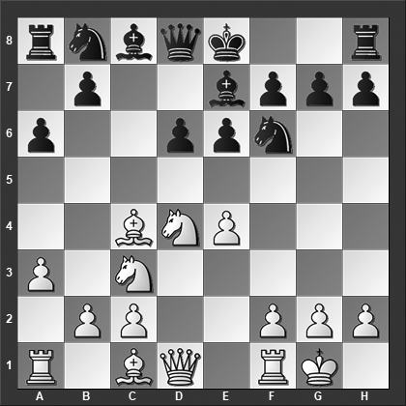

*What happens on 8...Nxe4?*

The main line is 8.Bb3 but there are quite a number of games with the text move as well. The idea is, of course, to tug the bishop back to a2 while a2–a3 at the same time helps to slow down Black's progress on the queenside.

**8...Nxe4?**

Now Black typically continues 8...0–0 and then after 9.Ba2, Black has two primary options:

9...Nc6 10.Be3 Bd7 11.Kh1 Qc7 12.f4 Na5 13.Qe2 Rac8 14.Rae1 Nc4 15.Bc1 b5 16.e5 Ne8 17.exd6 Bxd6 with more or less equal chances, Amonatov-Shomoev, Belgorod 2010.

9...b5 10.Qf3 Bb7 11.Qg3 Nc6 12.Nxc6 Bxc6 13.Bh6 Ne8 14.Rad1 b4 15.axb4 Rb8 16.Bc4 Rxb4 17.b3 Bh4 18.Qg4 was Hamdouchi-Vachier Lagrave, Pau 2012, and now 18...Rxc4 19.bxc4 f5 20.exf5 exf5 would have left Black with a comfortable game.

**9.Nxe4 d5 10.Qg4! g6 11.Rd1! Qc7 12.Bg5?!**

Not the most accurate. White has a few better alternatives:

12.Bf4 e5 13.Bxe5 Bxg4 14.Bxc7 dxc4 15.f3 with a clear advantage for White.

12.Qf3! is best 12...dxe4 13.Qc3 0–0?

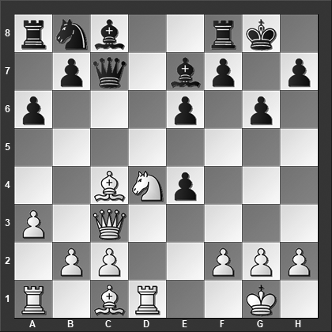

*How should White continue?*

(13...Rg8 14.Bb5+ Nc6 15.Bxc6+ bxc6 16.Bf4 is terrible for Black but relatively best) 14.Nf5!! (White also wins with 14.Nxe6 Bxe6 (or 14...fxe6 15.Bxe6+ Bxe6 16.Qxc7 Nc6 17.Qxb7) 15.Bh6 and Black loses the queen) 14...gxf5 15.Bh6 (The point) 15...f6 16.Bxe6+ Bxe6 17.Qxc7 Nc6 18.Bxf8 Bxf8 19.Qxb7 and White is winning.

**12...dxe4 13.Bxe7 f5**

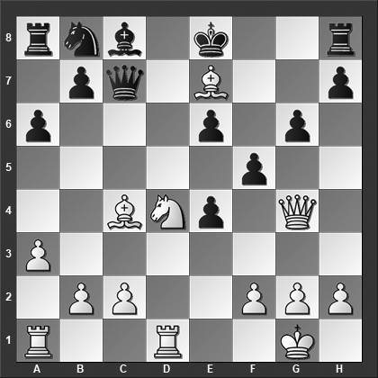

*What is White's best move?*

**14.Bd8!** Black resigned. This is probably mostly due to the shock value of White's move because after 14.Bd8! Qxc4 15.Qg3 0–0 16.Be7 Re8 17.Bd6 e5 18.Bxe5 Nd7 White is clearly better but Black didn't need to resign.

**1–0**

# **From Chapter 3**

# **Dragon & Accelerated Dragon Variations**

**Game # 46**

**A.Grosar (2220) – T.Marinsek (2470) B35**

Slovenian Ch 1991

**1.e4 c5 2.Nf3 Nc6 3.d4 cxd4 4.Nxd4 g6 5.Nc3 Bg7 6.Be3 Nf6 7.Be2 0–0 8.f4 d6 9.0–0 Bd7 10.Nb3 Qc7**

This is an unusual move in this position, especially after this move order. We can reach the same position after 7.Bc4 Qa5 8.0–0 0–0 9.Nb3 Qc7 10.Be2 d6 11.f4 Bd7.

**11.Bf3 Na5**

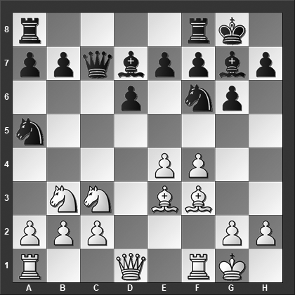

*What is White's best move?*

Black has a solid, even-headed alternative in 11...Rac8!? 12.Nd5 Nxd5 13.exd5 Na5 14.Nxa5 Qxa5 15.c3 a6 16.a3 Ba4 and the chances are about even, Ghassan-Kassis, Beirut 1998.

**12.e5! dxe5 13.fxe5 Nc4**

Or 13...Qxe5 14.Bd4 Qc7 and now instead of 15.Nxa5? (White should have played 15.Bxf6! exf6 16.Nxa5 wins material for White) 15...e5 16.Bxe5 Qxe5 17.Nxb7 when a draw was agreed upon, ½–½, in Supi-Blit, Sao Jose do Rio Preto 2012, even though Black is clearly better after 17...Rab8 18.Kh1 Qc7 19.Nd6 Rxb2.

**14.exf6 Nxe3 15.Nd5!** The refutation. Black resigned, because after 15...Nxd5, White plays 16.fxg7 before recapturing on g7, leaving White a piece up.

**1–0**

# **From Chapter 4**

# **Classical Variation**

# **including the Richter-Rauzer & Sozin Attack**

**Game # 74**

**J.Friedel (2551) – W.Schill (2229) B68**

Las Vegas 2009

**1.e4 c5 2.Nf3 d6 3.d4 cxd4 4.Nxd4 Nf6 5.Nc3 Nc6 6.Bg5 e6 7.Qd2 a6 8.0–0–0 Bd7 9.f4 Be7 10.Nf3 b5 11.e5 b4 12.exf6 bxc3 13.Qxc3 gxf6**

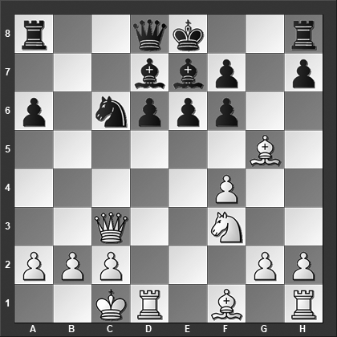

*Here White played 14.Rxd6 intending 14...Bxd6 15.Bxf6, how should Black respond to this?*

**14.Rxd6**

The main line is 14.Bh4, and now:

14...Rc8 15.Bxa6 Rc7 16.Bb5 d5 17.Nd4 Nb4 18.Bxd7+ Qxd7 19.Qb3 0–0 20.a3 Na6 21.Rhe1 Nc5 22.Qf3 Ne4 with chances to both sides, Hamdouchi-Durarbayli, Al Ain 2012.

14...d5 15.Kb1 Rc8 16.Qd2 Qc7 17.g4 a5 18.g5 f5 19.Bb5 Nb4 20.Bxd7+ Qxd7 21.c3 was Salgado Lopez-Acs, Paks 2011, and now 21...Nc6 22.Bf2 a4 would have promised Black adequate counterplay.

14...a5 15.Bb5 Nb4 16.Bxd7+ Qxd7 17.Kb1 Rc8 18.Qb3 0–0 19.f5 Nxc2 20.Ne5 Qd8 21.Rhf1 d5 22.fxe6, and here Black chose to force a draw with 22...Na3+ 23.Ka1 Nc2+ 24.Kb1 Na3+ 25.Ka1 Nc2+ 26.Kb1, ½–½, Paravyan-Eliseev, Loo 2016.

**14...Bxd6 15.Bxf6 Bb4!** White resigned at this point. The same happened in Salmensuu-Yrjola, 1994 and Oltean (2380) - Tischbierek (2495), Berlin 1990. Whereas a young Nakamura played on and somehow managed to save a draw after 15...Bb4 16.Bxh8 Bxc3 17.Bxc3, Nakamura-Lawson, New York 1999.

**0–1**

# **From Chapter 5**

# **Taimanov, Kan & Paulsen Variations**

**Game # 92**

**S.Marjanovic – D.Rajkovic B46**

Yugoslav Team Ch (Donji Milanovac) 1979

**1.e4 c5 2.Nf3 e6 3.d4 cxd4 4.Nxd4 Nc6 5.Nc3 a6 6.Be2 Nge7 7.Bf4 d6 8.Nxc6 Nxc6 9.Qd2 Be7 10.0–0 0–0 11.Rfd1 Ne5 12.Qd4**

White can also play 12.a4 Qc7 13.a5 b5 14.axb6 Qxb6 15.Be3 Qc6 16.Ra4 Nd7 17.Rc4 Qb7 18.f4 Rb8 19.b3 and White is control of the game, Apicella-Belkhodja, Val Maubuee 1990.

**12...Qc7 13.Rd2 Rd8 14.Rad1 h6??**

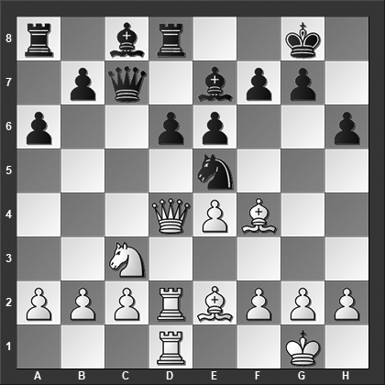

*Why is the text move a blunder?*

Black's best is 14...Bd7 15.Na4 Bxa4 16.Qxa4 b5 17.Qd4 Rac8 18.Qe3 Nc4 19.Bxc4 Qxc4 and Black has equalized, Balje-Jobe, IECC email 2000.

**15.Bxe5!** Black resigned. The key to Black's resignation is the second move in the sequence: 15.Bxe5! dxe5 16.Qc4! when Black cannot guard both queen and rook sufficiently.

**1–0**

# **From Chapter 6**

# **Kalashnikov & Sveshnikov Variations**

**Game # 107**

**L.Psakhis (2570) – A.Vaisser (2540) B33**

Paris Ch 1990

**1.e4 c5 2.Nf3 Nc6 3.d4 cxd4 4.Nxd4 Nf6 5.Nc3 e5 6.Ndb5 d6 7.Bg5 a6 8.Na3 b5 9.Bxf6 gxf6 10.Nd5 Bg7 11.Bd3 Ne7 12.Nxe7 Qxe7 13.c4 f5 14.Qh5??**

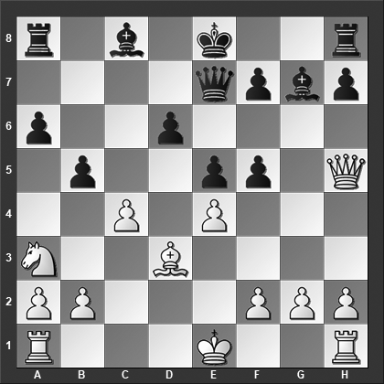

*How should Black continue?*

14.0–0 is the main line, but the text move looks natural enough to be played regularly.

**14...d5 15.cxd5**

Or 15.0–0 fxe4 16.Bc2 bxc4 17.Ba4+ Bd7 18.Bxd7+ Qxd7 19.f4 exf4 20.Rxf4 0–0 21.Rf5 Rad8 22.Rd1 c3 23.bxc3 Qa4 and Black is winning, Nayhebaver-Pacher, Banska Stiavnica 2016.

**15...fxe4** Here White resigned in our main game since 16.Bxe4 is met by 16...Qb4+, winning a piece. In another game, White tried something else and also failed: 15...fxe4 16.Bc2 Qb4+ 17.Ke2 e3 18.Kf1 Bg4 and White resigned because the e-pawn will decide the day, 0–1, Blanco Acevedo-Huerga Leache, Linares 2015. **0–1**