# 

# **From Chapter** **1**

# **Alapin Variation 2 c3**

**Game # 8**

**E.Sveshnikov (2508) – P.Haugli (2362) B22**

Riga 2004

**1.e4 c5 2.c3 Nf6 3.e5 Nd5 4.Nf3 Nc6 5.Bc4 Nb6 6.Bb3 d5 7.exd6 Qxd6 8.Na3 Bf5**

Two other options for Black are:

8...a6 9.0–0 Bf5 10.d4 cxd4 11.Nxd4 Nxd4 12.cxd4 e6 13.Qf3 Qd7 14.d5 Nxd5 15.Rd1 Bxa3 16.bxa3 0–0 with chances to both sides, Howell-Vidit, Douglas 2016.

8...Be6 9.d4 cxd4 10.Nb5 Qd7 11.Bxe6 Qxe6+ 12.Be3 Qd7 13.Nbxd4 Nxd4 14.Bxd4 Qa4 15.Qb3 Qxb3 16.axb3 Nc8 17.b4 and White is in command of the game, Tan-Zhou Jianchao, Kuala Lumpur 2017.

**9.d4 cxd4 10.Nb5 Qd7**

Or 10...Qd8 11.Nfxd4 Nxd4 12.Nxd4 Bg6 13.0–0 e6 14.Qf3 Bc5 15.Be3 Qe7 16.Nc6 Qd6 17.Rfd1 Qxc6 18.Qxc6+ bxc6 19.Bxc5 and White has a large positional plus, Stripunsky-Reis, Arlington 2013.

**11.Nbxd4 Nxd4**

Black has also tried 11...Bg6 12.0–0 e6 13.Qe2 Nxd4 14.Nxd4 Bc5 15.Rd1 Bxd4 16.Rxd4 Qc6 17.h4 when White has a clear advantage, Codenotti-De Filomeno, Montecatini Terme 2011.

**12.Nxd4 Be4 13.0–0 e6 14.Qe2 Bd5**

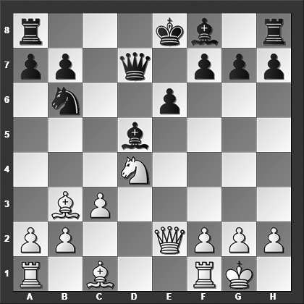

*What did White play here that made Black resign the game?*

**15.Rd1** Black resigned!

While the resignation seems wildly premature, it is pretty clear that Black is serious trouble and is, in fact, likely losing. However, resigning early never won any games, but let's look at what could have happened... 15.Rd1, and now:

15...0–0–0 16.c4 Bc6 17.Bg5 Qxd4 18.Bxd8? (I'm not sure why White didn't just take the queen, for example, 18.Rxd4 Rxd4 19.Be3 Re4 20.Bc2 Re5 21.f4 Ra5 22.Bd2 and White is winning) 18...Qf4 19.Bxb6 axb6 20.Qd2 Qf6 21.Bc2 Be7 22.b4 and although White somehow managed not to win this position, he has a decisive advantage at this point, Harley-Tavoularis, Birmingham 2006.

15...Bxb3 16.axb3 a6 17.Be3 (White could improve with 17.Bg5! Qc7 (or 17...Be7 18.Nf5) 18.Nxe6 and Black can resign) 17...Rd8 18.Nb5 Qc6 19.Rxd8+ Kxd8 20.Rd1+ Nd7 was played in Marcelin-Gaillard, Montigny le Bretonneux 1999, and now 21.Bg5+ Ke8 22.Nd4 Qb6 23.b4 e5 24.b5 would have left White with a large advantage.

**1–0**

# **From Chapter 2**

# **The Grand Prix Attack**

**Game # 33**

**J.Radulski (2375) – V.Spasov (2540) B23**

Bulgarian Ch 1994

**1.e4 c5 2.Nc3 Nc6 3.Bb5 Nd4 4.Bc4 e6 5.Nge2 Nf6 6.0–0 a6 7.d3 d5**

The main line is 7...b5 8.Bb3 Nxb3 9.axb3 Bb7 10.f4 d5 11.e5 d4 (or 11...Nd7 12.d4 Qc7 13.Be3 g6 14.Qe1 Be7 15.Qf2 h5 16.Rfd1 c4 17.bxc4 Qxc4 and Black has equalized, Cherniaev-R.Pert, Hinckley Island 2009) 12.exf6 dxc3 13.fxg7 Bxg7 14.bxc3 Rg8 15.Rf2 Bxc3 16.Nxc3 Qd4 17.Kf1 Qxc3 with more or less even chances, Tiviakov-Shirov, Wijk aan Zee 2010.

**8.exd5 exd5?**

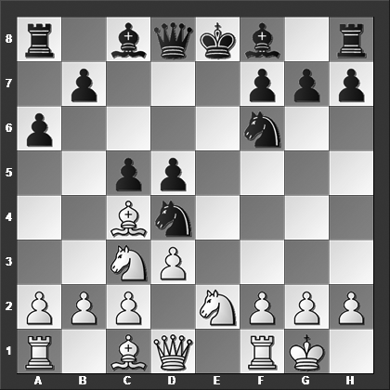

*How should White best continue?*

Here Black must insert 8...b5!, for instance, 9.Bb3 Nxb3 10.axb3 b4 11.Ne4 Qxd5 12.Nf4 Qc6 13.Qf3 Bb7 14.Nxf6+ gxf6 15.Qxc6+ Bxc6 with chances to both sides, Bogaudinov-Vokhidov, Moscow 2017.

**9.Nxd5! Nxd5**

Or 9...Nf3+ 10.gxf3 (10.Kh1 Nxd5 11.Nc3 Nxh2?? (also 11...Nd4 12.Qh5 Ne6 13.Bxd5 is much better for White) 12.Re1+ Ne7 13.Qh5 g6 14.Qxh2 b5 15.Nd5 Kd7 16.Bg5 and Black could have resigned at this point, Genzling-Gschnitzer, Germany 2012) 10...Nxd5 11.Re1 Be7 12.Ng3 Be6 13.f4 g6 14.f5 gxf5 15.Qh5 Nf6 16.Qe2 Nd5 17.Qh5 Nf6 was played in Kotsur-Potapov, Tashkent 2009, and now 18.Qf3 Qd7 19.Bg5 Kd8 (also 19...0–0–0 20.Rxe6 fxe6 21.Re1 is a disaster for Black) 20.Rxe6 fxe6 21.Re1 Qc6 22.Qxc6 bxc6 23.Rxe6 with a position that should be an easy win for White

**10.Nxd4 cxd4 11.Qh5 Ne7?**

Also 11...Be6 12.Re1 Be7 (Black's best defense is 12...Nc7!? 13.Bxe6 Nxe6 14.Rxe6+ Be7 15.Bg5 g6 16.Rxe7+ Qxe7 17.Qh4 with clearly better chances for White) 13.Rxe6 Nf6 14.Rxf6 gxf6 15.Qxf7+ Kd7 16.Bf4 Qa5 17.Qe6+ (Or 17.Be6+ and Black resigned, 1–0, in Lobzhanidze-Di Nicolantonio, Vaujany 2013, which is perfectly reasonable in light of 17...Kd8 18.Bd6 Re8 19.Bxe7+ Rxe7 20.Qf8+) 17...Kd8 18.Re1 Re8 19.Re4 Qc5 20.b4 Qa7 21.Qd5+ Kc8 22.Qa5, and with mate in just a few moves, Black resigned, 1–0, Hamdouchi-Wirig, France 2003.

**12.Qxf7+ Kd7 13.Re1 Kc6 14.Bg5 b5 15.Qf3+** Black resigned.

**1–0**

# **From Chapter 3**

# **The Closed Sicilians**

**Game # 40**

**C.Renner (2437) – E.Schmittdiel (2483) B20**

German Bundesliga 1999

**1.e4 c5 2.d3 g6 3.g3 Bg7 4.Bg2 e5 5.Nh3 Nc6 6.0–0 Nge7 7.f4 d6 8.c3**

A logical attempt is the immediate 8.f5 which we see rather frequently in this type of position. If Black is not entirely sure what is going on, it can go downhill very quickly. Here, however, Black played it well: 8...f6 (Black can also accept the pawn with 8...gxf5 but 9.Qh5 0–0 10.exf5 f6 can seem unpleasant for Black) 9.Be3 h5 10.fxg6 Bg4 11.Qd2 Qd7 12.Nf2 Be6 13.h3 0–0–0 14.Nc3 f5 15.exf5 Nxf5 with a sharp position and chances to both sides, Hillarp Persson-Tarjan, Douglas 2015.

With 8.Nc3 we would be entering a rather normal Closed Sicilian. The main game move gives the game its own direction.

**8...0–0 9.Na3 h6**

Or 9...d5 10.f5 (if 10.exd5 then 10...Nxd5 11.fxe5 Nxe5 12.Nf2 Be6 is fine for Black) 10...gxf5 11.Qh5 f6 (11...Qd7! looks like a good improvement) 12.exf5 Rb8 13.Nc2 b5?! (13...Qe8!? is more solid) 14.g4 Kh8

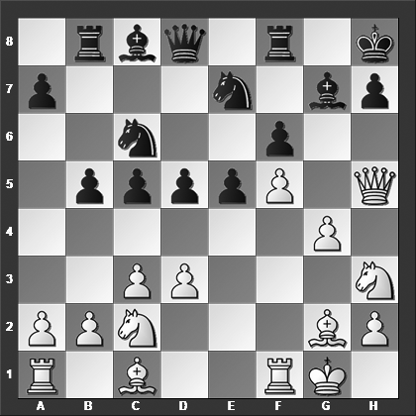

(Black could likely do better here, e.g., 14...Qe8 15.Qh4 b4 16.c4 dxc4 17.dxc4 Bb7 or 14...b4 15.c4 dxc4 16.dxc4 Nd4 17.Nxd4 Qxd4+ 18.Nf2 Qxc4, in both cases with chances to both sides) 15.g5!? Bxf5 16.Rxf5! Nxf5 17.g6 Nh6 (Black should probably have played 17...Bh6, for instance, 18.Qxf5 Bxc1 19.Rxc1 Ne7 20.Qf2 hxg6 21.Qxc5 Qd7 with chances to both sides) 18.Bxh6 Rb7?? (A very strange meltdown by Black. Instead 18...Bxh6! 19.Qxh6 Rb7 20.Ng5 fxg5 21.g7+ Rxg7 22.Qxc6 c4 would have kept the game competitive even if White is better) 19.Bd2 and Black of course resigned, 1–0, Renner-Sandkamp, Germany 1999.

**10.f5!?**

The standard plan once again.

**10...gxf5 11.Qh5 fxe4**

Or 11...f4 12.gxf4 exf4 13.Bxf4 Ne5 14.Bxh6 N7g6 15.Nf2 with better chances for White.

**12.dxe4 Be6 13.Bxh6 f6**

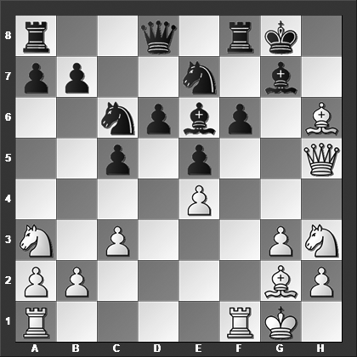

*How should White best continue?*

**14.Ng5!** Black resigned. After 14.Ng5 fxg5 15.Qxg5 Nf5 16.Rxf5 Qxg5 17.Rxg5 Rf7 (17...Kh7 18.Bxg7 Rf7 19.Nb5) 18.Nb5 White will end up with one or two extra pawns and an easily winning position.

**1–0**

# **From Chapter 4**

# **The Rossolimo Attack with 3...g6**

**Game # 48**

**D.King (2520) – K.Klundt (2410) B31**

Kecskemet 1988

**1.e4 c5 2.Nf3 Nc6 3.Bb5 g6 4.0–0 Bg7 5.Re1 e5 6.Bxc6 dxc6 7.d3 Qe7 8.Nbd2 Nf6**

8...Nh6 has also been played in nearly 100 games in my database. The idea is to play ...f7–f6 and transfer the knight to f7.

**9.a3**

The main line is 9.Nc4 which has been featured in numerous grandmaster encounters, e.g., 9...Nd7 10.a4 0–0 11.a5 Rd8 12.Bd2 Nf8 13.Rb1 f6 14.b4 Be6 15.Ne3 b6 16.bxc5 (or 16.axb6 axb6 17.bxc5 and here a draw was agreed upon, ½–½, Anand-Leko, Monte Carlo 2004) 16...bxc5 17.Qc1 Bf7 18.Qa3 Rab8 19.a6 Ne6 20.Nc4 Rdc8 21.Rb7 Rxb7 22.axb7 with a clear advantage for White, Areshchenko-Yakovich, Moscow 2007.

**9...0–0 10.b4 Nd7**

Some alternatives for Black are:

10...Be6 11.bxc5 Qxc5 12.a4 b5 13.Bb2 Nh5 14.c3 Qb6 15.d4 Rfd8 16.axb5 Qxb5 17.Qc2 with marginally better chances for White, Motwani-Lanka, Vienna 1991.

10...Rd8 11.Nc4 Bg4 12.Rb1 Nd7 13.Na5 Rdb8 14.h3 Bxf3 15.Qxf3 Nf8 16.Be3 cxb4 17.axb4 Qc7 18.c3 Ne6 was seen in Grechihin-Van der Weide, Groningen 1996, and here 19.Ra1 Rc8 20.Red1 b6 21.Nb3 would have left White with some pressure although Black's position is perfectly solid and playable.

**11.bxc5 Nxc5 12.a4 Rd8 13.Ba3 Be6 14.Qe2 f6??**

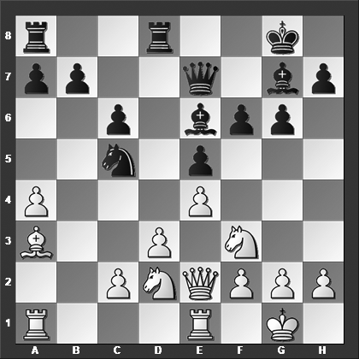

*What is White's best move?*

Black should have played 14...b6 15.Reb1 f6 16.a5 Bf8 and now White should not get greedy with 17.axb6?! axb6 18.Rxb6 Qf7 19.Rxc6? because after 19...Qe8 20.Rb6 Nd7 Black wins material.

**15.c3!** Black resigned because he doesn't have a good of meeting the threat of d3–d4, winning a piece.

**1–0**

# **From Chapter 5**

# **The Rossolimo Attack with Other 3rd Moves**

**Game # 63**

**I.Glek (2566) – S.Arkhipov (2531) B30**

Russian Team Ch (Tomsk) 2001

**1.e4 c5 2.Nf3 Nc6 3.Bb5 e6 4.0–0 Nge7 5.Re1 a6 6.Bxc6 Nxc6 7.d4 cxd4 8.Nxd4 Qc7 9.Nxc6 bxc6 10.e5**

White tries to lay a clamp on Black's dark squares.

**10...Bb7**

The alternatives are:

10...d5 11.exd6 (11.c4 Bc5 (11...Rb8!? 12.Nc3 a5 is fine for Black) 12.Be3 Qb6 13.Nc3 Bxe3 14.Rxe3 d4 15.Na4! Qa5 was played in G.Jones-Hamitevici, Reykjavik 2014, when 16.Rd3 Qxe5 17.Rxd4 0–0 18.c5 would have left White with a clear advantage.) 11...Bxd6 12.Qh5 0–0 13.Nd2 Rb8 14.Nc4 Rb5 15.Qh3 Be7 16.a4 Rd5 17.Bd2 e5 and Black cannot complain about the outcome of the opening, Stankovic-Managadze, Achaea 2017.

10...c5 11.Nd2 d5 12.c4 Be7 13.Qg4 0–0 14.Nf3 f5 15.Qg3 Bb7 16.Bh6 Rf7 17.Rac1 d4 and Black already has a comfortable game, Ramiro Ovejero-Almagro Llamas, Monzon 2016.

**11.Nd2 c5**

Black has also tried 11...d6 12.exd6 Bxd6 13.Qh5 0–0 14.Nc4 c5 15.Bd2 Rad8 16.Bc3 Bf4 17.Qg4 f5 (17...Bxh2+ 18.Kh1 f5 19.Qh3 Bf4 20.Ba5 Qe7 21.Bxd8 Rxd8 is okay for Black) 18.Qh4 Rd7 19.f3 and White has the marginally better chances, Pedzich-Kogan, Krynica 1997.

**12.Nc4 Bd5**

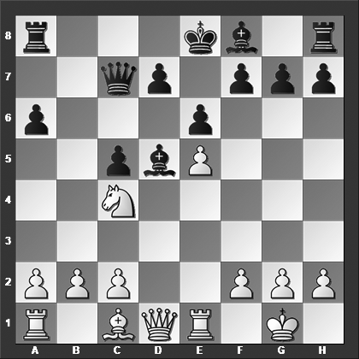

*How should White continue?*

**13.Nd6+! Bxd6**

This loses outright, but 13...Ke7 14.c4 Bb7 15.Qh5 isn't much of an alternative.

**14.Qxd5!** Black resigned. This was the exact same sequence seen in Fernandez Siles-Teran Alvarez, Palma de Mallorca 2009. After 14.Qxd5 exd5 15.exd6+ Black ends up a piece down.

**1–0**

# **From Chapter 6**

# **The Moscow Attack**

**Game # 80**

**Xu Yuhua (2501) - Zhao Xue (2428) B51**

HeiBei zonal (women) 2001

**1.e4 c5 2.Nf3 d6 3.Bb5+ Nd7 4.d4 cxd4 5.Qxd4 Ngf6 6.Bg5 e6 7.Nc3 Be7 8.0–0–0 0–0 9.Bxd7 Bxd7 10.e5**

White has a couple of alternatives:

10.Qd3 Bc6 11.Nd4 Rc8 12.h4 a6 13.Kb1 b5 14.f3 Bb7 15.g4 Nd7 16.Qe3 Ne5 17.b3 Rc5 18.Nce2 Qd7 19.Bxe7 Qxe7 with chances to both sides, Glek-Piceu, Belgium 2011.

10.Bxf6 gxf6 11.Kb1 Qa5 (or 11...Bc6 12.Qe3 Qa5 13.Nd4 Kh8 14.f4 Rg8 15.g3 Qc5 16.Rhe1 Rac8 17.Qe2 Bd7 18.Nb3 with somewhat better chances for White, Kornev-Sidorov, Samara 2002) 12.e5! fxe5 13.Nxe5 Bc6 14.Nxc6 bxc6 15.Rd3 e5 16.Qg4+ Kh8 17.Qd7 Rae8 18.Qxc6 and White is winning, Pridorozhni-Pozin, Khanty-Mansiysk 2009.

**10...dxe5 11.Nxe5 Be8**

Or 11...Bc6 12.Nxc6 bxc6 13.Qxd8 (13.Rd3 Nd5 14.Bxe7 Qxe7 15.Rg3 f6 16.Re1 Rad8 17.Qc4 Qd7 18.Rd3 Qf7 19.a3 Rc8 20.Ne4 with a small but clear positional plus for White, Jezek-Popov, Bad Salzungen 1960) 13...Rfxd8 14.f3 h6 15.Bd2 Nd5 16.Ne4 Nb6 17.b3 Nc4 18.c3 Nxd2 19.Rxd2 f5 and Black has taken the initiative in the ending, Degraeve-Peredun, Guelph 2002.

**12.Qh4 Qb6 13.Rd3 Rd8**

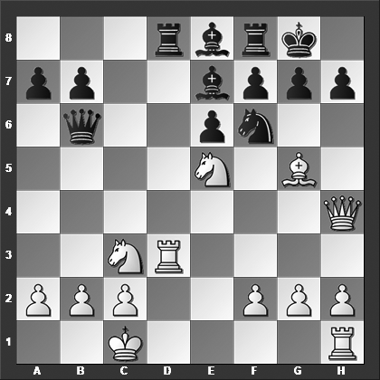

**14.Rh3** *This is a good analysis exercise. Why did Black resign at this point?*

Black resigned because there is no satisfactory defense although it may take a little exploring before reaching that conclusion, e.g., 14.Rh3,and now: 14...Qd4 (14...h6 15.Bxh6 Nd5 16.Bg5 Bxg5+ 17.Qxg5 Nxc3 (17...Qxf2 18.Qxd8 Qf4+ 19.Kb1 Qxe5 20.Nxd5 Qxd5 21.Qxd5 exd5 with a won ending) 18.bxc3 Qxf2 19.Ng4 and White wins) 15.f4 Qd2+ 16.Kb1 h6 17.Bxh6 Qxg2 18.Re1 Nh5 19.Qxe7 Qxh3 20.Qxd8 gxh6 21.Rg1+ Kh7 22.Ne2 and here Black cannot prevent the lethal penetration of White's pieces: 22...Qf5 23.Qe7 Rh8 24.Ng6 Rg8 25.Nf8+ Kh8 26.Rxg8+ Kxg8 27.Qxe8 and White wins.

**1–0**

# **From Chapter 7**

# **2.Nf3 d6 Specialties**

**Game # 89**

**P.Zarnicki (2520) – F.Quiroga (2440) B53**

Buenos Aires 1995

**1.e4 c5 2.Nf3 d6 3.d4 cxd4 4.Qxd4 Bd7 5.c4 Nc6 6.Qd2 g6 7.b3 Bg7 8.Nc3 Nf6 9.Bb2 0–0 10.h3 Qa5 11.Bd3 Rac8**

Black has tried several other moves at this juncture:

11...a6 12.a3 b5 13.b4 Qb6 14.cxb5 axb5 15.0–0 Na7 (15...Ne5 16.Nxe5 dxe5 17.Rfd1 Qb7 is about even) 16.Nd5 Nxd5 17.Bxg7 Kxg7 18.exd5 e5 19.dxe6 fxe6 20.Be2 Rad8 21.Rad1 Nc8 22.Qd4+ Qxd4 23.Nxd4 with an advantage for White in the endgame, Shkapenko-Wojtaszek, Poznan 2004.

11...Nh5!? 12.0–0 Nf4 13.Qxf4 Bxc3 14.Bxc3 Qxc3 15.Rad1 a5 16.e5 Nxe5 17.Nxe5 dxe5 with equal chances, Damjanovic-Soltis, Reggio Emilia 1970.

11...Nb4 12.Bb1 Nc6 13.0–0 a6 14.a3 Ne5 15.Nxe5 dxe5 16.b4 Qc7 17.Ba2, Gipslis-Schurade, Germany 1998, and now 17...e6 18.Qe3 b5 19.c5 Bc6 20.Bb3 Rfd8 when Black is somewhat worse.

**12.0–0 Qh5 13.Ne2**

Or 13.Be2 Bh6 14.Qd3 Nb4 15.Qb1 Bxh3! 16.gxh3 Qxh3 17.Bc1 Rc5 18.Nd5 was Vetemaa-Fullbrook, Vancouver 2000, and now 18...Bxc1 19.Qxc1 Qg4+ 20.Kh1 Qxe4 21.Qe3 Nbxd5 22.Qxe4 Nxe4 23.cxd5 Rfc8 with better chances for Black. Instead White should have played 18.e5! Bxc1 19.Qxc1 Qg4+ 20.Kh1 Qh3+ 21.Nh2 Rxe5 with even chances.

**13...Bh6 14.Qd1 a6**

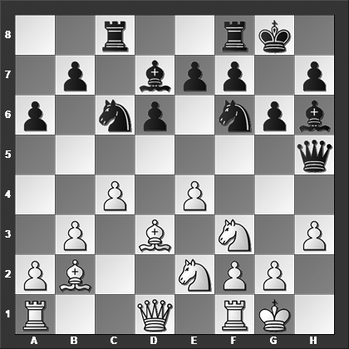

*How should White best continue?*

**15.e5!** The black queen is trapped. There is no way to save it without heavy material losses and therefore Black resigned.

**1–0**

# **From Chapter 8**

# **2.Nf3 e6 Specialties**

**Game # 92**

**D.Andreikin (2713) – V.Bologan (2672) B40**

World Rapid Ch (Khanty-Mansiysk) 2013

**1.e4 c5 2.Nf3 e6 3.g3 d5 4.exd5 exd5 5.d4 Nc6 6.Bg2 Bg4 7.0–0 cxd4 8.h3 Bh5 9.g4**

Or 9.Re1+ Be7 10.g4 Bg6 11.Nxd4 Nf6 12.Nxc6 (12.c4! is probably even better for White) 12...bxc6 13.Qe2 (White should have opted for 13.c4 0–0 14.cxd5 Nxd5 with chances to both sides) 13...h5 14.Nc3 hxg4 15.hxg4 Kf8 16.Bf4 Bd6 and Black is clearly better, Klein-Swinkels, Wijk aan Zee 2013.

**9...Bg6 10.Nxd4**

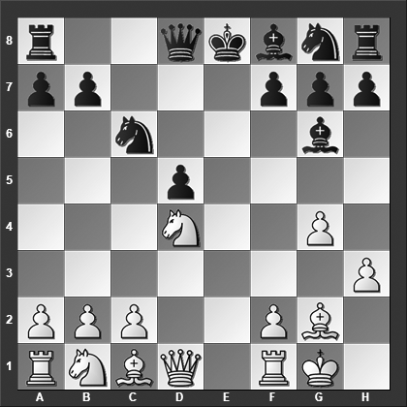

**10...Nf6**

Or 10...Be7 11.Nxc6 (11.c4!?) 11...bxc6 12.c4 Nf6 13.cxd5 cxd5 14.Nc3 0–0 15.Nxd5 Nxd5 16.Qxd5 Qc7 17.Be3 and Black is a pawn down without matching compensation, Davletbayeva-Kursova, Chengdu 2015.

**11.c4! Be7 12.g5 Ne4 13.cxd5 Nxd4?**

Black should have played 13...Qxd5 14.Nxc6 Qxd1 15.Rxd1 bxc6 although 16.Nc3 Nxc3 17.Bxc6+ Kf8 18.bxc3 Rc8 19.Bg2 Bf5 20.Rd5 Be6 21.Ra5 favors White.

**14.Qxd4 Qb6? 15.Qa4+** Black resigned as he loses the knight on e4.

**1–0**

# **From Chapter 9**

# **O'Kelly (2...a6), Ultra-Fianchetto (2...g6) and Nimzowitch (2...Nf6)**

**Game # 108**

**C.Storey (2268) – V.Meijers (2496) B27**

European Union Ch (Liverpool) 2008

**1.e4 c5 2.Nf3 b6 3.Nc3 Bb7 4.d4 cxd4 5.Nxd4 a6 6.Bc4 e6 7.0–0 b5**

Rather than this curious, time-wasting pawn move, which nevertheless is playable, the Swedish Grandmaster Slavko Cicak has played 7...Qc7 several times:

8.Bb3 Nf6 9.Re1 Bd6 10.Nf3 Nc6 11.Bg5 Ne5 12.Bxf6 Nxf3+ 13.Qxf3 gxf6 14.g3 Be5 15.Re3 h5 and Black is clearly better, Westerinen-Cicak, Andorra 2000.

8.Qe2 Bd6 9.Kh1 Be5 10.Be3 Nc6 11.Nxc6 Qxc6 12.Nd5 b5 13.Bb3 Nf6 14.Rad1 Nxe4!? 15.Bc1 (15.f3!?) 15...exd5! 16.Bxd5 Qxd5 17.Rxd5 Bxd5 18.Rd1 Bc6 19.f3 and here a draw was agreed upon, ½–½, in Womacka-Cicak, Germany 2000. A possible continuation was 19...0–0 20.fxe4 Rae8 21.Re1 Re6 when Black cannot be worse.

**8.Bb3 b4**

Black could also consider 8...Nc6, for instance, 9.Re1 Bb4 10.Nxc6 dxc6 11.Qg4 Nf6 12.Qxg7 Rg8 13.Qh6, Kusiak-Bokros, Slovakia 2014, and now 13...Bxc3 14.bxc3 c5 15.Bg5 Ng4! would have left Black with better chances.

**9.Nd5 Bc5!?**

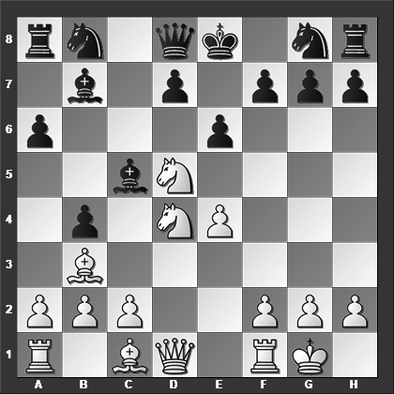

*White's previous move was natural enough, but how should he follow up after Black's last move?*

Or 9...exd5 10.exd5 Bc5 11.Nf5 with excellent compensation for the piece, yet this is definitely preferable over what happened in the game.

**10.Be3!**

This "quiet" move gives Black immediate headaches because of the unguarded bishop on c5.

**10...exd5 11.Nf5! d6**

Also 11...Bxe3 12.Nd6+ Kf8 (or 12...Ke7 13.Nxb7 Qb6 14.Qxd5) 13.fxe3 is an unmitigated disaster for Black.

**12.Bxd5! Bc6?**

Now it tumbles apart rather quickly. But even after the stronger 12...Nc6 Black is lost: 13.Qf3 Qf6 14.Bxc5 dxc5 15.Nd6+ Qxd6 16.Qxf7+ Kd8 17.Qxb7 and Black loses his extra piece, ending up two pawns down.

**13.Bxc5 Nh6**

Or 13...dxc5 14.Bxf7+, winning Black's queen.

**14.Bxc6+** Black resigned.

**1–0**

# **From Chapter 10**

# **Other Specialties**

**Game # 126**

**V.Zhelnin (2489) – I.Gulkov (2491) B23**

Tula 2000

**1.e4 c5 2.Nc3 Nc6 3.Nge2 e5 4.Nd5 Nce7 5.Nec3 Nxd5 6.Nxd5 Be7**

A couple of alternatives are:

6...Ne7 7.Bc4 d6 8.0–0 Nxd5 9.Bxd5 Be7 10.f4 exf4 11.d4 cxd4 12.Qxd4 Bf6 13.Qc4 0–0 14.Bxf4 Bxb2 15.Rab1 with fabulous activity and excellent compensation for the pawn, Hamdouchi-Sardana, Doha 2014.

6...Nf6 7.Bc4 Be7 8.d3 d6 9.f4 (or 9.0–0 0–0 10.Nxe7+ Qxe7 11.f4 exf4 12.Bxf4 Ng4 13.Qf3 Be6 14.Qg3 Rad8 15.Bb3 a6 16.Bd5 Bxd5 17.exd5 Ne5 with a position that is very close to equal, V.Georgiev-Tiviakov, Plovdiv 2003) 9...exf4 10.Bxf4 0–0 11.0–0 Nxd5 12.Bxd5 Be6 13.c3 Bxd5 14.exd5 Bf6 15.Qf3 Re8 16.Rae1 Qd7 17.Qg3 Rxe1 18.Rxe1 and White has some initiative but objectively speaking the position is quite equal, Galkin-Womacka, playchess.com INT 2007, provided Black now would play 18...Be7 (instead of 18...Rd8 which allowed 19.Bxd6, winning a pawn).

**7.Qh5 d6 8.Bc4 Be6 9.d3 Rb8?**

Black's position is uncomfortable but wasting time on preparing a pawn advance such as ...b7–b5 should not take preference at this point in time. Instead, 9...Qc8, threatening ...Bg4 would have forced White to make a course correction. Now, on the other hand, White's initiative develops faster.

**10.f4 g6 11.Qf3 Bxd5 12.Bxd5 Nf6 13.Bb3 h6?**

Black should have played 13...0–0 although the situation is far from pleasant after 14.0–0 b5 15.f5 with at least a clear advantage for White.

**14.0–0 Kf8**

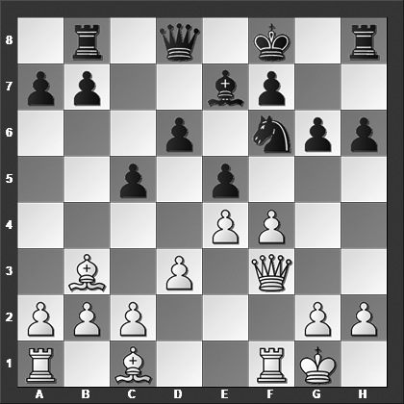

*Which move did White play that made Black resign?*

**15.Bd2** Here Black resigned which seems very premature. However, once you start analyzing the position then you quickly realize what terrible shape Black is in 15.Bd2 Rh7 16.fxe5 dxe5 17.Bc3 Qd6 18.Qg3 Nd7 19.Rf3 Kg8 20.Raf1 Rf8 21.Qf2 and Black can no longer guard the f7 pawn anymore.

**1–0**