# 

# **From Chapter 1**

# **Dutch – Main Lines**

**Game # 2**

**J.Aagaard (2517) – D.Palo (2551) A87**

Danish Team Ch 2013

**1.d4 f5 2.g3 Nf6 3.Bg2 g6 4.Nf3 Bg7 5.c4 0–0 6.b4 d6 7.0–0 e5 8.dxe5 dxe5 9.Qb3 e4**

Or 9...Qe8 10.Nc3 h6 11.e4 f4 12.Bb2 c6 13.gxf4?! Nh5 14.Ne2 exf4?! (14...Nxf4 15.Nxf4 Rxf4 looks normal and better) 15.Bxg7 Nxg7 16.c5+ Kh8 17.Qc3 a5 18.bxa5 Bg4? (18...Kh7!?) 19.Rab1 with clearly better chances for White, Li R.-J.Christiansen, Doha 2015.

**10.c5+**

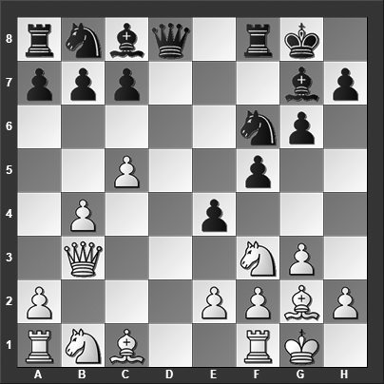

*How should Black best meet this check?*

White has tried a few other things at this point:

a) 10.Ng5 h6 (10...Nc6!? looks like a worthwhile improvement) 11.Rd1 Qe8 12.Nh3 g5 13.f4 g4 14.Nf2 Be6 15.Na3 a5 16.b5 Nbd7 17.Bb2 Nc5 18.Qc2 Qe7 19.e3 c6 20.Bf1 Rac8 21.Rac1 Rfd8 22.Rxd8+ Rxd8 23.bxc6 bxc6 24.Nb1 Nfd7 and draw agreed, ½–½, in Kortschnoj-Spassky, St Petersburg 1999.

b) 10.Rd1, and now it is Black's turn to choose:

b1) 10...Qe7 11.Nd4 Rd8 12.Bb2 c5 13.bxc5 Nc6 14.e3 Be6 15.Nd2 Bf7 16.Rac1 Ne5 17.Rb1 Qxc5 18.Ba3 Qa5 and Black has taken over the initiative, W.Schmidt-Chojnacki, Trzcianka 2016.

b2) 10...Qxd1+!? 11.Qxd1 exf3 12.Bxf3 (12.exf3 Nfd7 13.Nc3 Bxc3 14.Rb1 Re8 is fine for Black) 12...Ne4 13.Bxe4 fxe4 14.Qd5+ Kh8 (14...Rf7! seems safest) 15.Nc3 Bxc3 16.Bh6, and now, rather than 16...Bxa1 (16...c6 17.Qxe4 Bf5 18.Qe3 Bxa1 19.Bxf8 Nd7 with playable but not entirely comfortable position for Black) 17.Bxf8 Nc6 18.b5 when White was already winning in Lyngsjo-Frisvold, Helsingor 2008, Black should have played;

b3) 10...Qe8 11.Nd4 Kh8 12.Nc3 Nc6 13.Ncb5 Nxd4 14.Nxd4 Be6 15.Bf4 Rf7 16.Rac1 h6 17.Qb2 Ng4 18.f3 with a sharp position and chances to both sides, Rausis-Capuano, Castellaneta 2000.

**10...Qd5!**

After this move, White is essentially lost, but his collapse comes sooner than anticipated...

**11.Ne5?**

The choice for White would have been 11.Nd4 although after 11...Qxb3 12.axb3 Nd5 13.Rd1 Nxb4 14.e3 N8c6 he would have had a position that is lost at grandmaster level.

**11...Qxb3 12.axb3 Ng4** White resigned. Losing an exchange this early on was enough for the famous author and coach to call it quits.

**0–1**

# **From Chapter** **2**

# **Dutch - Anti-Dutch**

**Game # 17**

**M. Cebalo (2418) – E. Vasiukov (2451) A80**

Sibenik 2014

**1.d4 f5 2.Bg5 g6 3.e3 Nh6**

The main line is 3...Bg7 which has been played hundreds of times. The text move is a lot rarer.

**4.h4**

White plays the most aggressive move planning to push the h-pawn forward to disrupt Black's normal development.

A couple of alternatives are:

4.Bc4 d5 5.Bxh6 (White can also consider 5.Be2 Nf7 6.Bh4 Bg7 7.Nf3 although 7...c5 8.c3 is at best marginally better for White) 5...Bxh6 6.Bd3 0–0 7.f4 c5! 8.c3 Qb6 9.Qd2 Bd7 (9...Bg7!?) 10.Nf3 Bb5?! (10...Bg7!?) 11.Bxb5 Qxb5 12.Na3 and draw agreed, ½–½, in Donchenko-Grafl, Germany 2015, which is definitely premature as White has a pleasant position.

4.Nf3 Nf7 5.h4 Bg7 6.Nbd2 d6 7.Bc4 Nc6 8.c3 h6 9.Qb3 Rf8 10.Bxf7+ Rxf7 11.h5 gxh5 12.Bh4 and White has the initiative, Parulava-Junker, Germany 2001.

**4...Nf7 5.Bf4**

Another try for White is 5.Bd3 d5 6.Nf3 Bg7 7.c4 Be6 8.cxd5 Bxd5 9.Nc3 Nc6 10.Rc1 h6 11.Bf4 and White has the better chances, Dale-Halpin, Bangkok 2017.

**5...d6**

5...Bg7 6.Nc3 d6 7.Nf3 c6 8.Qd2 e5 9.dxe5 dxe5 10.Qxd8+ Kxd8 11.0–0–0+ Ke7 12.Bg3 Be6 and Black has completely equalized, Dragomirescu-Hernandez Moya, Baku 2016.

**6.Nf3 Nd7 7.Bc4 Bg7??**

Black entirely misses White's very simple threat. He should have played 7...c6, although 8.Bxf7+ Kxf7 9.h5 (The immediate 9.Ng5+ Kg8 is harmless for Black) 9...Bg7 10.Nc3 is better for White.

**8.Bxf7+ Kxf7 9.Ng5+ Kf6**

An unfortunate necessity because any retreat with the king is met with Ne6 and material losses to follow.

**10.Nc3 c6**

Or 10...e6 11.d5 e5 12.Ne6 Qg8 13.Bg5+ Kf7 14.Nb5 and White is winning.

**11.Qf3! e5**

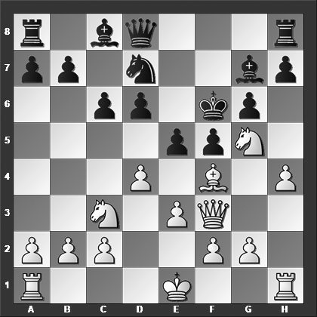

*How should White best continue?*

Or 11...Qa5 12.0–0–0 Bh6 13.e4 and White is winning.

**12.Qd5!! Qe7 13.Nxh7+** And Black resigned. He is getting mated on the very next move.

**1–0**

# **From Chapter 3**

# **Benonis & Benko Gambit**

**Game # 58**

**J.Nogueiras Santiago (2455) – R.Vaganian (2590) A43**

Mexico 1980

**1.d4 Nf6 2.Nf3 c5 3.d5 b5 4.Bg5 Ne4 5.Bh4 Qa5+ 6.Nbd2 Bb7 7.a4 Bxd5**

The alternative is 7...Nxd2, and now:

8.Qxd2 Qxd2+ 9.Nxd2 Bxd5 10.e4 Bb7 11.axb5 a6 12.bxa6 Nxa6 13.Nc4 Nc7 14.Rxa8+ Bxa8 15.Bd3 was seen in Rogozenco-Brandenburg, Wijk aan Zee 2007, and now 15...Ne6 16.Kd2 g5 17.Bg3 Bg7 would offer Black a playable position even though White still has the upper hand)

8.Nxd2 Qb4 9.e4 a6? (9...g6 10.Qb1 bxa4 11.c3 Qb6 12.Nc4 Qc7 13.Qc2 is 'only' clearly better for White) 10.axb5 Qxb2 11.bxa6 Bxa6 12.Bxa6 Nxa6 13.0–0 g5 14.Bxg5 Bg7 15.Ra4 and White is completely winning, G.Jones-Chapman, Torquay 2013.

7...bxa4 8.c3 f5 9.Rxa4 Qb6 10.Nc4 Qh6 11.e3 (11.Ne3! is possibly even stronger) 11...g5 12.Bg3 Nxg3 13.fxg3 Bg7 14.Na5 Bc8 15.g4 and White has a very clear advantage, Akobian-Ramirez, Saint Louis 2012.

**8.axb5 Qb4**

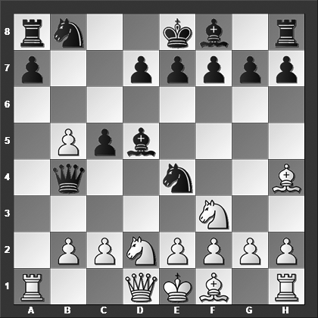

*How should White best continue?*

Retreating the queen is safer: 8...Qb6 9.e3 Nxd2 10.Nxd2 g6 11.Nb3 Bb7 12.Na5 d5 13.Be2 Bg7 14.0–0 Nd7 15.c4 with a large, likely decisive, advantage for White, A.Kovacs-Sinka, email 2011.

**9.c4! Bb7**

Or 9...g5 10.cxd5 Nxd2 11.Qxd2 gxh4 12.Qxb4 cxb4 13.b6 a5 14.b7 Ra7 15.Rc1 and Black could safely have resigned, Vidit-Le Quang Long, Ho Chi Minh City 2012.

**10.Qc2**

The black queen is trapped; the rest is desperation.

**10...a6 11.Ra4 axb5 12.Rxb4 Ra1+ 13.Nb1 cxb4 14.Nfd2** Black resigned.

**1–0**

# **From Chapter 4**

# **Trompowsky Attack**

**Game # 66**

**P.Wells (2501) – A.Shirov (2709) A45**

Gibraltar 2006

**1.d4 Nf6 2.Bg5 c5 3.Bxf6 gxf6 4.d5 Qb6 5.Qc1 f5 6.c4 Bh6 7.e3 f4 8.exf4 Bxf4 9.Qxf4 Qxb2 10.Ne2 Qxa1 11.Nec3 Qb2**

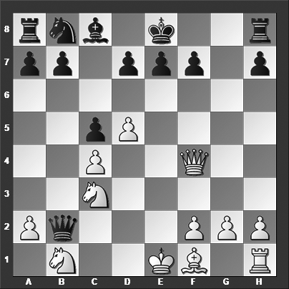

*How should White continue?*

11...d6 12.Qd2 Rg8 13.g3 Rg4? (I don't know what this is all about but it looks ridiculous. Instead 13...b5!? 14.cxb5 a6 to get some pieces into play and obtain counterplay makes perfect sense) 14.f4 b5? (14...a6!?) 15.cxb5 a6 16.b6! (denying Black the counterplay he was hoping for) 16...Nd7 17.Be2 Rb8 18.0–0 Rxb6 19.Bxg4 Qb2 20.Qxb2 Rxb2 21.Rf2 and even though Black miraculously managed to save a draw later on, at this point White is completely winning, Vitiugov-Dubov, Khanty-Mansiysk 2013.

**12.d6 Qc2**

The main alternative is 12...Nc6 but that too does not score too well for Black after 13.Bd3, and now:

13...b5 14.cxb5 Nb4 15.0–0 (15.Be4! is even better) 15...Bb7 16.Bc4 (16.Qe5! is much better, e.g., 16...0–0–0 17.Qxc5+ Kb8 18.dxe7 Rde8 19.Qd6+ Ka8 20.Be4 and the party is soon over for Black) 16...e6 17.Qg5 Kf8 18.Qh6+ Kg8 19.Re1 Nd5 20.Bxd5 Bxd5 21.Qg5+ Kf8 22.Qh6+ Kg8 23.Re2 and Black resigned, 1–0, A.Smirnov-A.Ivanov, St Petersburg 2006.

13...Nb4 14.Be4! Nc2+ 15.Kd1 Nd4 16.Qe5 0–0 17.dxe7 Ne6 18.Qf5 and Black resigned, 1–0, Rusev-Arnaudov, Pamplona 2009.

13...exd6? 14.0–0 Ne5 15.Qf6 0–0 16.Nd5 Re8 17.Qg5+ Ng6 18.Nf6+ Kf8 19.Qh6+ Ke7 20.Nd5+ Kd8 21.Bxg6 hxg6 22.Nbc3 A picturesque position, Black resigned, 1–0, Hodgson-Van der Wiel, Amsterdam 1994.

**13.Qe3** Here the tactical wizard behind the black pieces decided to resign. It looks ridiculously early, but once you examine 13.Qe3 Nc6 14.Bd3 Qb2 15.0–0 a little closer you will realize that Black's position is, in fact, hopeless, which Shirov didn't want to look at on the board.

**1–0**

# **From Chapter 5**

# **The Anti-Indians**

**Game # 103**

**S.Begun (2380) – A.Kapengut (2465) A49**

Minsk 1978

**1.Nf3 Nf6 2.b3 g6 3.Bb2 Bg7 4.g3 d6 5.d4 c5 6.c4?!**

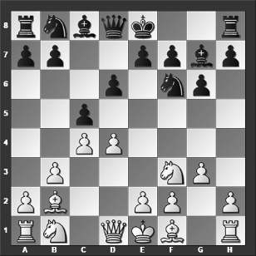

*This looks like a natural move but it is, in fact, an inaccuracy. Now Black can grab the initiative, can you see how?*

The correct and most popular move for White is 6.Bg2 although Black has no troubles equalizing against this move, for instance, 6...cxd4 7.Nxd4 d5 8.c4 dxc4 9.bxc4 Qb6 10.Qc2 Nc6 11.Nxc6 bxc6 12.0–0 0–0 and Black has nothing to worry about, Anurag-Matamoros Franco, Forni di Sopra 2017.

**6...Ne4!**

Just like this! White now is facing issues on both the a1–h8 and a5–e1 diagonals.

**7.Bg2 Qa5+ 8.Kf1**

Instead of this ugly move, White has tried the alternatives quite a few times:

8.Nfd2 Nxd2 (8...f5? 9.Bxe4! fxe4 10.Bc3 Qc7 11.dxc5 Bxc3 12.Nxc3 e3 13.fxe3 Qxc5 14.Nd5 and Black does not have enough compensation for the pawn, Korley-Bekker Jensen, Svendborg 2015) 9.Bc3 (9.Qxd2 Qxd2+ 10.Nxd2 Bxd4 11.Bxd4 cxd4 leaves Black a pawn up) 9...Qb6 10.dxc5 Nxb1 11.Bxg7 Qb4+ 12.Kf1 Rg8 (12...Nd2+ 13.Kg1 Rg8 14.Bd4 dxc5 15.Be3 Nxc4 16.bxc4 Nc6 17.Rb1 Qxc4 18.Bd5 Qa6 19.Qb3 leves White with adequate compensation for the pawn(s), Kosic-Tomic, Paracin 2013) 13.Bb2 Nd2+ 14.Kg1 dxc5?! (Black should have played 14...Nxc4 15.Qd4 Na6 16.Bc3 Qxc5 17.bxc4 Qxd4 18.Bxd4 Nc5 when White doesn't have sufficient compensation for the pawn) 15.Rc1 Nxb3 16.axb3 Nc6 17.Bxc6+ bxc6 was seen in Sargissian-Li Chao, Huaian 2016, and now 18.Kg2 a5 19.Qd3 would have been marginally better for White.

8.Nbd2 Nc6 9.e3 Bg4 (Both 9...Bf5!? and 9...0–0 10.0–0 Nxd2 11.Qxd2 Qxd2 12.Nxd2 cxd4 13.Bxc6 dxe3 14.Bxg7 Kxg7 15.Bf3 exd2, which leaves Black a pawn up, are better for Black) 10.h3 Bxf3 11.Bxf3 Nxd2 (Or 11...Nc3 12.Qc2 cxd4 13.Bxc6+ bxc6 14.exd4 Bxd4 15.Kf1 Qf5 16.Qxf5 gxf5 17.Nf3 Bf6 18.Rc1 Ne4 19.Bxf6 Nxf6 20.Nd4 and White wins back the pawn with more or less equal chances in the endgame) 12.Qxd2 Qxd2+ 13.Kxd2 cxd4 14.Bxc6+ bxc6 15.Bxd4 Bxd4 16.exd4 a5 17.Kc3 and draw agreed, ½–½, in Saric-Rogulj, Sibenik 2011.

**8...Nc6 9.e3 0–0 10.Ne1 f5 11.f3?**

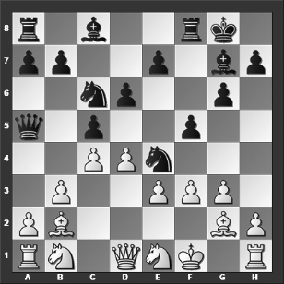

*What is Black's best move?*

White should have played the more solid 11.Nc2 although 11...b5! 12.f3 Nf6 is still rather promising for Black.

**11...cxd4 12.exd4 e5!**

Black has also played the weaker move 12...f4? which allows White the possibility to close things up a bit with 13.g4 Ng5?! (13...Nf6! is considerably better) 14.Bc3 Qb6 15.h4 Nf7 16.d5 Nce5 17.Bd4 Qd8 with chances to both sides, which obviously suits White since he is lost in the game continuation in our main game; here White eventually won the game, Pavlovic-Ivanisevic, Sozina 2004.

**13.fxe4 fxe4+ 14.Kg1**

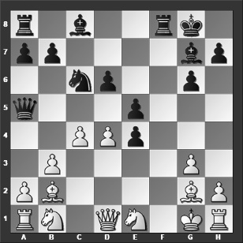

**14...Bg4!**

The bishop is untouchable because of ...Qxe1+.

Black can also play 14...exd4! 15.Bxe4 Bh3 16.Nf3 Rae8 and White is hopelessly lost.

**15.Qd2 Bh6!** A beautiful conclusion to the game. White resigned.

**0–1**

# **From Chapter 6**

# **Budapest & Fajarowicz Gambits**

**Game # 109**

**P.Lukacs (2460) – P.Horvath (2489) A52**

Budapest 2002

**1.d4 Nf6 2.c4 e5 3.dxe5 Ng4 4.Bf4 Bb4+ 5.Nd2 d6 6.exd6 Qf6 7.Nh3 Nxf2 8.Kxf2 Bxh3 9.e3**

The theoretical main line is 9.g3, and now:

9...Bc5+ 10.e3 (10.Ke1 Bf5 11.Qb3?! (Better, but still fine for Black is 11.Bg2 Nc6 12.dxc7 0–0 with chances to both sides) 11...0–0 12.Qxb7 Nd7 13.Ne4 Bxe4 14.Qxe4 cxd6 15.Bh3 Rfe8 16.Qc2 Ne5 and Black is clearly in command, Walter-Beikert, Germany 2009) 10...Bf5 11.dxc7 Nd7 12.h4 Qxb2?! 13.Kg1 Qb6 14.Qb3 Bb4? (14...Qf6!?) 15.c5! Nxc5 16.Qb2 Bxd2 17.Qxg7 and White is winning, Sage-Fister, ICCF email 2005.

9...Bf5 10.e4 (10.dxc7 Nc6 11.e4 Bd7 12.Kg2 can also be tried for White) 10...g5 11.exf5 gxf4 12.Qe2+ Kf8 13.Qe7+ Qxe7 14.dxe7+ Kxe7 15.Ne4 Nd7 16.a3 fxg3+ 17.hxg3 Nf6 18.axb4 Nxe4+ 19.Kg2 Ng5 20.g4 Kf6 (20...Rhd8 and draw agreed, ½–½, was Mauro-Morin, email 2001) 21.Kg3 a6 22.Bg2 c6 23.Rh6+ Kg7 24.Rd6 and White has the better chances in the endgame, I.Jelen-Mikac, Ljubljana 1992.

9...Bxf1 10.Rxf1 Qd4+ 11.Kg2 Bxd6 12.Qb3 Nd7?? (Black had to play 12...0–0 13.Qxb7 Nd7 14.Nf3 Qf6 15.Bxd6 Qxd6 16.Rad1 Qe7 17.e4 Nf6 18.b3 and White is only a small measure better) 13.Be3 Qe5 14.c5 Bxc5 (or 14...Nxc5 15.Qxf7+ Kd8 16.Nc4 Qe4+ 17.Rf3 Ne6 18.Nxd6 cxd6 19.Rd1 and Black resigned, 1–0, Komarov-Chatalbashev, St Raphael 1998) 15.Qxf7+ Kd8 16.Bxc5 Qxc5 17.Rad1 Kc8 and now instead of 18.Qxd7+ Kxd7 19.Ne4+ Kc6 20.Nxc5 Kxc5 21.Rf7 Rhe8 which allowed Black to survive in C.Horvath-Mohr, Austria 2004, White should have played 18.Ne4! Qc6 19.Rd4! b6 20.Rc4 and White is winning.

**9...g5 10.Ne4**

White can also play 10.dxc7 which leads to massive complications after 10...Nc6 11.Ne4 Qxb2+ 12.Be2 gxf4 13.gxh3 f5 14.Nd6+ Kd7!! which my computer interestingly assesses as equal! There is plenty to analyze, even for fun.

**10...Qxb2+ 11.Kf3??**

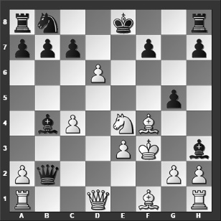

*What is Black's best move?*

Here my computer recommends 11.Be2 gxf4 12.gxh3 fxe3+ 13.Kxe3 Qe5 14.dxc7, and now Black can force a draw with 14...Bc5+ 15.Kf3 Qf5+ 16.Kg3 Qe5+ which appear to be best play by both sides.

**11...f5!**

11...gxf4?? throws the win away: 12.gxh3?? (White should have played 12.Rb1 Qe5 13.Qd5 Nc6 14.Qxe5+ Nxe5+ 15.Kxf4 Bxd6 16.Nxd6+ cxd6 17.gxh3) 12...Nd7?? (12...f5! wins) 13.exf4 f5 14.Ng5 0–0–0 15.Rb1 Qc3+ 16.Qd3 Rde8 17.Qxc3 Bxc3 and somehow White has found a way to survive, Sundararajan-Spiller, Genting Highlands 1998.

**12.gxh3 fxe4+ 13.Kxe4 gxf4 14.Qh5+ Kd8** White resigned.

**0–1**

# **From Chapter 7**

# **Old Indian & Minor d-pawn Specials**

**Game # 125**

**H.Schussler (2455) – Y.Seirawan (2605) A41**

Reykjavik 1986

**1.d4 d6 2.c4 e5 3.Nc3 g6 4.dxe5 dxe5 5.Qxd8+ Kxd8 6.Nf3 Bg7 7.e3 c6 8.b3**

Or 8.Be2 Nd7 9.0–0 Nh6 10.Rd1 f5 11.e4 Ke7 as played in Laine-Tuominen, Jyvaskyla 1997, and now White has the tactical sequence 12.Bg5+ Ke8 13.exf5 gxf5 14.Nxe5 Nxe5 15.Rd8+ Kf7 16.Bh5+ Ng6 17.Rxh8 Bxh8 18.Bxh6 available.

**8...e4 9.Nd4 f5 10.Ba3 Nf6 11.0–0–0 Kc7??**

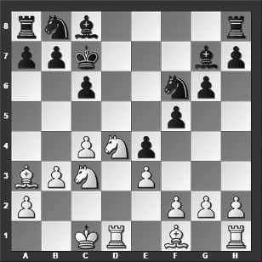

*How should White continue?*

Black should have played the necessary and solid 11...Ke8 12.Be2 Bf8 13.Bxf8 Kxf8 14.Kb2 Kg7 after which he is at most slightly worse.

**12.Ndb5+! cxb5 13.Nxb5+ Kb6 14.c5+ Ka5 15.Rd4** With mate being delivered on the next move, Black resigned. A terrible defeat for the American top grandmaster.

**1–0**