# 

# **From Chapter 1**

# **Minor Flank Openings**

**Game # 9**

**K. Sakaev (2540) – E.Sveshnikov (2525) A01**

Gausdal 1992

**1.b3 e5 2.Bb2 Nc6 3.e3 Nf6 4.Bb5 Bd6 5.Na3 Na5 6.Be2 a6 7.Nc4 Nxc4 8.bxc4 Qe7 9.a4 0–0 10.Nh3?!**

This looks a little odd and we all know the rule about knights on the a- and h-files. But White has a specific idea in mind. 10.Nf3 e4 11.Nd4 Be5 12.0–0

**10...Bc5 11.f4?**

This is a very ambitious move and the idea behind White's previous move.

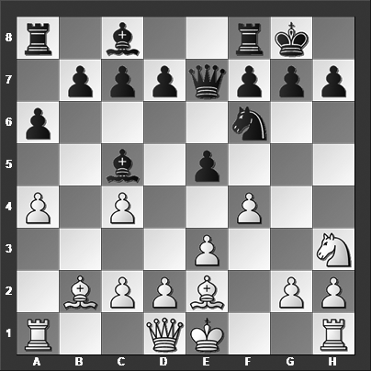

*Is there a way for Black to take advantage of White's last move?*

**11...Bxe3! 12.Bxe5**

Black's little combination wins a pawn after 12.dxe3 Qb4+ 13.Qd2 Qxb2, and now 14.0–0 Ne4 15.Qd3 Nc5 16.Qd2 e4 is obviously better for Black. White is trying to avoid losing that pawn but lands himself in even trouble.

**12...Ba7 13.Nf2 d6 14.Bb2 Re8 15.d4?**

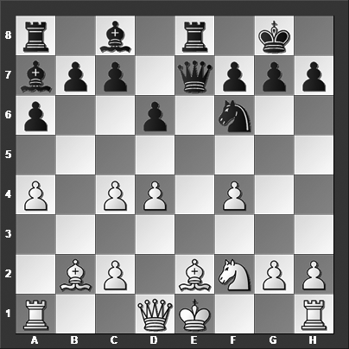

*How should Black continue?*

**15...Ng4!**

This is a nasty move. White cannot capture it: 15...Ng4 16.Nxg4 (16.Ra3 is met by 16...Ne3, followed by ...Nxg2+. White cannot take advantage of Black's weak back rank with 16.0–0 Qxe2 17.Re1 because of 17...Qxf2+, and Black is winning) 16...Bxg4 and White loses the bishop on e2.

**0–1**

# **From Chapter 2**

# **Reti & King’s Indian Attack**

**Game # 19**

**S.Martinovic (2517) – M.Prusikin (2532) A05**

Austria League 2015

**1.Nf3 Nf6 2.g3 d5 3.Bg2 c6 4.d3 Bf5 5.Nh4 Bg6 6.Nxg6 hxg6 7.0–0 Nbd7 8.c4**

8.e4 dxe4 9.dxe4 e5 10.a4 a5 11.Nd2 Qc7 12.Qe2 Bc5 13.Nc4 Nb6 14.Ne3 0–0 15.c3 Qe7 and although I would rather play White in this type of position, objectively the chances are quite even, Karasev-Sidorov, St Petersburg 1999.

**8...dxc4 9.dxc4 Qa5**

I'm not entirely sure the idea behind this move because to swing the queen to the kingside to attack with ...Qh5 is easily parried with an h2–h3. Instead, the normal move is 9...e6, for instance, 10.Nd2 Qb6 11.Qc2 a5 12.e3 a4 13.Rb1 Qa5 14.Nf3 Qf5 15.Nd4 Qxc2 16.Nxc2 Bd6 17.b4 axb3 18.axb3 Ke7 19.Bb2 and draw agreed, ½–½, C.Horvath-Z.Almasi, Hungary 1992.

**10.Nc3 Nb6 11.Qb3**

White can also consider 11.Qc2!?, and now: 11...0–0–0 (11...Nxc4 12.Ne4 Nxe4 13.Bxe4 Ne5 14.Bf4 Nd7 15.Bxc6 bxc6 16.Qxc6 Rd8 (or 16...Qd8 17.Rac1 and Black is completely busted) 17.Bc7 Rc8 18.Qxd7+ Kxd7 19.Bxa5 and White is simply a pawn up for nothing) 12.b3 e6 13.a3 g5 14.h3 (White cannot allow ...g5–g4 as it is then followed by ...Qh5) 14...Be7 15.Bb2 Qf5 16.e4 Qh7 17.Rfd1 with a comfortable game for White.

**11...Ng4?!**

A rather bold and not particularly impressive idea.

**12.Ne4!**

12.h4 is unnecessary, but also fine for White.

**12...Nxh2?**

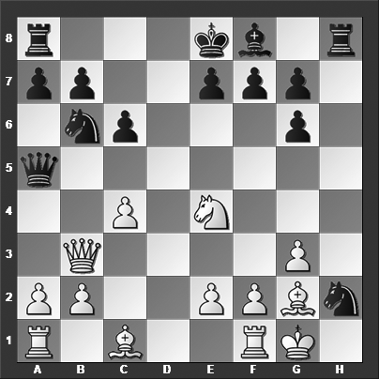

*Why is this a bad idea?*

Relatively best is 12...Nf6 13.Rd1 Nxe4 14.Bxe4 e6 15.h4 Be7 16.Be3 with a clear plus for White.

**13.Rd1!**

Amazingly, after this move, Black is completely lost.

**13...Qa4**

The alternatives do not inspire confidence either: 13...e6 14.c5 Bxc5 15.Bd2 Bxf2+ 16.Nxf2 Qh5 17.Bc3 and White is winning. 13...Qh5 14.c5 and Black can resign.

**14.Nc5** Black resigned on account of 14.Nc5 Qxb3 15.axb3 e6 16.Nxb7 Be7 17.Be3 and Black's position collapses entirely.

**1–0**

# **From Chapter 3**

# **English Opening: Indian, Dutch & Slav Lines**

**Game # 67**

**M.Bobotsov – B.Larsen A17**

Buesum 1969

**1.c4 Nf6 2.Nc3 e6 3.Nf3 Bb4 4.g3 0–0 5.Bg2 d5 6.0–0 dxc4 7.Qa4 Na6**

A main alternative for Black is 7...a5 8.Qb5 (Black doesn't have any problems after 8.a3 Bd7 9.Qc2 Bxc3 10.dxc3 Bc6 11.Bg5 h6 12.Rad1 Nbd7 13.Bxf6 Qxf6 14.Ng5 Qxg5 15.Bxc6 Nc5 16.Bb5 Rad8 17.Bxc4 a4 18.Bb5 and draw agreed, ½–½, Mikhalchishin-Speelman, Baku 1983) 8...Bd7 9.Qxc4 Bc6 10.a3 Be7 11.Re1 Qe8 12.Nd4 Bxg2 13.Kxg2 c6 14.e4 b5 15.Qe2 Bc5 and Black has more or less equalized, Kozul-Postny, Sibenik 2016.

**8.a3 Bd7 9.Nb5**

Or 9.Qc2 Bd6 10.d4 cxd3 11.exd3 c6 12.d4 Nc7 when White has some compensation for the pawn, Bagheri-Ghaem Maghami, Teheran 2016.

**9...Qe8 10.Nfd4? e5! 11.Bxb7 exd4 12.Bxa6**

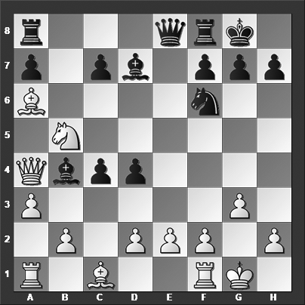

*What is Black's best move?*

**12...Bh3! 13.axb4 Qe4 14.Bb7 Qxb7 15.f3 Bd7** White resigned. **0–1**

# **From Chapter 4**

# **English Opening: 1.c4 e5**

**Game # 80**

**A.Skripchenko (2456) – R.Przedmojski (2405) A22**

Koszalin 1999

**1.e4 c6 2.c4 e5 3.Nf3 Nf6 4.Nc3 Bb4 5.Be2 d6 6.Qc2 Bg4**

Or 6...a5 7.0–0 Bg4 8.Na4 Nbd7 9.Rd1 0–0 10.d4 Bxf3 11.gxf3 exd4 12.Rxd4 Qe7 13.Be3 Ne8 14.Rad1 b6 15.f4 and White has somewhat better chances thanks to his more space and bishop pair, Landenbergue-Gruenenwald, Switzerland 2011.

**7.Qb3**

7.a3 Ba5 8.0–0 0–0 9.d3 Nbd7 10.h3 Bxf3 11.Bxf3 Bb6 12.b4 a5 13.Rb1 axb4 14.axb4 Re8 was about equal in Perez Mitjans-Cuartas, Barbera del Valles 2007.

**7...Na6**

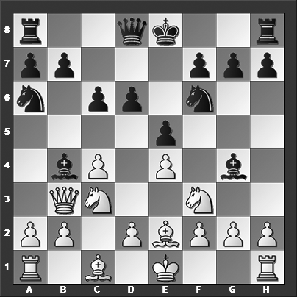

*Here White intending the following line: 8.a3 Bxc3 9.Qxb7 winning one or two pawns before recapturing the bishop on c3. What did White miss?*

**8.a3**

The chances would have been about equal after 8.0–0 0–0 9.h3 Bxf3 10.Bxf3 Bc5.

**8...Bxc3 9.Qxb7??**

Or 9.Qxc3 Nxe4 10.Qe3 f5 and Black has won a pawn.

**9...Nc5 10.Qxc6+ Ke7!**

This is probably the move White had forgotten to consider.

**11.dxc3 Rc8 12.Qb5 Bd7** The queen is trapped, if 13.Qb4, then 13...a5 closes the trap entirely.

**0–1**

# **From Chapter 5**

# **Symmetrical English: 1.c4 c5**

**Game # 118**

**L.B.Hansen (2545) – N.De Firmian (2575) A33**

Danish Team Ch 1998

**1.Nf3 c5 2.c4 Nc6 3.d4 cxd4 4.Nxd4 e6 5.Nc3 Nf6 6.g3 Qb6 7.Ndb5 Ne5 8.Bf4 d6**

A major alternative for Black is 8...Nfg4, and now:

9.e3 a6 10.Qa4 Ra7 (10...g5 11.Bxe5 Nxe5 12.0–0–0 Be7 13.Be2 0–0 14.Nd4 Qb4 15.Qxb4 Bxb4 16.f4 gxf4 17.gxf4 and White has the better chances, Vachier Lagrave-Dominguez Perez, Istanbul 2012) 11.h3 axb5 (11...g5 12.hxg4 gxf4 13.gxf4 axb5 14.Qxb5 Qxb5 15.Nxb5 Nc6 16.Nxa7 Nxa7 17.Bd3 Bg7 18.0–0–0 and White was in command of the game, Matlakov-Grischuk, Dubai 2014) 12.Qxb5 Qc6 13.hxg4 Qxh1 14.Bxe5 Qc6 15.Bd4 Ra8 16.a3 Be7 17.Qh5 Kf8 18.0–0–0 b6 with a messy position and chances to both sides, Topalov-Caruana, Moscow 2016)

9.Qa4 g5 10.Bxe5 Qxf2+ 11.Kd1 Nxe5 12.Nc7+ Kd8 13.Nxa8 Qd4+ 14.Kc2 Nxc4 15.e4 (Or 15.Kb3 Nd2+ 16.Kc2 and soon a draw was agreed in Carlsen-Dominguez Perez, Linares 2009) 15...Ne3+ (The crazy line 15...Qd2+! 16.Kb3 Qxb2+ 17.Kxc4 leads to a draw after 17...Bg7 18.Qa5+ b6 19.Qxg5+ f6 20.Qb5 Ba6 21.Qxa6 f5 and despite White being up a rook and two minor pieces he cannot win) 16.Kb3 Qd2 17.a3 Qc2+ 18.Ka2 Qxa4 19.Nxa4 Nxf1 20.Rhxf1 and White is clearly better, Nakamura-Karjakin, Zuerich 2015.

**9.Bg2 a6**

9...Nfg4 10.0–0 a6 11.Na4 Qd8 12.Na3 Ng6 13.Bd2 Rb8 was played in Wells-Jakovenko, Warsaw 2005, and now 14.h3 N4e5 15.Qb3 would have left White with the upper hand.

9...Be7? 10.c5 Qxc5 11.Be3 Qc4 12.b3 (12.Nxd6+ Bxd6 13.Qxd6 Ned7 14.a4 a6 15.Rd1 is completely hopeless for Black) 12...Qb4 13.Nc7+ Kd8 was Romero Holmes-Karjakin, Benidorm 2003, and now the quiet 14.Qc2 would have been decisive.

**10.Qa4 Nfd7**

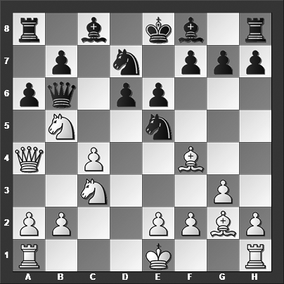

*How should White continue?*

**11.c5!! Nxc5**

11...axb5 12.Qxa8 Qxc5 13.Be3 Qc7 14.Nxb5 isn't any better.

**12.Nxd6+ Ke7 13.Nd5+!!** With mate looming in just a few moves, Black resigned.

**1–0**