# 

# **From Chapter 1**

# **The Slav Defense**

**Game # 23**

**H.Teske (2550) – T.Jugelt (2400) D17**

Bad Zwischenahn.2012

**1.Nf3 d5 2.c4 c6 3.d4 Nf6 4.Nc3 dxc4 5.a4 Bf5 6.Ne5 Nd5 7.Nxc4 Nd7 8.f3 Nb4**

The main line is 8...e5.

**9.e4 Bg6 10.Bg5**

Another try for White is 10.Be3 e6 11.Be2 Be7 12.0–0 0–0 13.Qb3 f5 14.Rad1 Qc7 (14...f4!?) 15.Na3 Bf7 16.Bc4 f4 was Flumbort-Vajda, Budapest 2002, and now 17.Bf2 e5 18.Bxf7+ Rxf7 19.Nc4 exd4 20.Rxd4 would have left White with a clear advantage.

**10...Nb6?!**

Black should played 10...f6 11.Be3 e5 12.d5 Bc5 13.a5 0–0 with chances to both sides.

**11.Qb3 a5?!**

Here Black should have considered 11...h6 12.Bh4 Nxc4 13.Bxc4 Qb6 14.Ne2 (not 14.a5 because of 14...Nd3+ 15.Kd2 Qxb3 16.Bxb3 Nf4 and Black is still in the game) 14...Na6 15.Qc2 with a clear advantage for White.

**12.d5! Qc7 13.Rc1 e6**

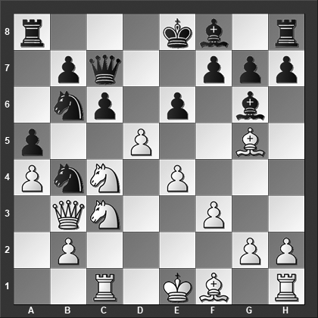

*How should White continue?*

**14.Nb5!! cxb5 15.Nxb6** Black resigned. **1–0**

# **From Chapter 2**

# **Queen’s Gambit Accepted**

**Game # 36**

**A.Shirov (2706) – A.Motylev (2641) D20**

FIDE World Ch Knock-Out (Moscow) 2001

**1.d4 d5 2.c4 dxc4 3.e4 c5 4.d5 Nf6 5.Nc3 b5 6.Bf4 Ba6**

6...Qa5 is the alternative but this too scores poorly for Black.

**7.Nf3 b4 8.Bxb8 bxc3**

The alternatives are:

8...Qxb8 9.Qa4+ Nd7 10.Qxa6 bxc3 11.b3!? (11.bxc3 Qb2 12.Rd1 Qxc3+ 13.Nd2 g6 14.Qxc4 Qxc4 15.Bxc4 Rb8 is fully playable for Black although probably slightly better for White) 11...Qf4 12.Qxc4 g6 13.Qxc3 Qxe4+ 14.Be2 Qb4 15.Qxb4 cxb4 16.0–0 with a lead in development and marginally better chances for White.

8...Rxb8 9.Qa4+ Qd7 10.Qxa6 bxc3 11.bxc3 Nxe4 12.Ne5 Qb5 (12...Qf5 13.f4 wins for White) 13.Qxa7 Nxc3 14.Rc1 with a large advantage for White.

**9.Qa4+ Qd7 10.Qxa6 cxb2 11.Rb1 Rxb8 12.Ne5**

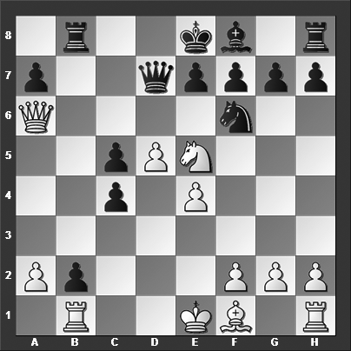

*Where should Black's queen go? To b5 or b7?*

In another game played shortly after our main game, the Danish top grandmaster and later coach for world champions Anand and Carlsen, Peter Heine Nielsen continued 12.Bxc4 Rb6 13.Qa3 Nxe4? 14.Rxb2?! (14.Ne5! looks decisive) 14...Qb7 15.Rxb6 Qxb6 16.0–0 f6 17.Qa4+ Kd8 18.d6 e5 19.Be6 Qb7 20.Qa5+ and Black resigned,1–0, P.H.Nielsen-Karjakin, Hastings 2002 because of 20...Qb6 21.Rb1!.

**12...Qb7**

This was a trick question. The answer is neither!

The alternatives are:

12...Qc7 13.Qa4+ Nd7 14.Nxc4 (or 14.Nc6 Rb6 15.Bxc4 g5! - to grab control of the dark squares - 16.e5 Bg7 17.0–0 e6 and White impressive-looking center falls) 14...g6 15.Qc6 (15.Rxb2 Rxb2 16.Nxb2 Bg7 17.Nc4 0–0 is given as slightly better for Black in ChessBase Magazine, but that is certainly at least a slight advantage, Black's position is much easier to play) 15...Kd8 16.Qxc7+ (16.e5 and draw agreed, ½–½, was Fellner-Olbrisch, correspondence 1991, but even here Black is doing okay, for instance, 16...Bg7 17.f4 f6 18.Rxb2 Rxb2 19.Nxb2 fxe5 and the sizzle in White's position is running out) 16...Kxc7 17.Rxb2 Rxb2 18.Nxb2 Bg7 19.Nd1 Rb8 20.Bd3 Ne5 and even though White eventually won the game, Black has a comfortable advantage at this point thanks to his much more mobilized pieces, Ivanisevic-Chatalbashev, Antalya 2002.

12...Qd6 13.Qa4+ (or 13.Nc6 Qf4 14.Nxb8 Qc1+ 15.Ke2 Qc2+ 16.Ke3 Qc3+ 17.Kf4 Qc1+ 18.Kf3 Qc3+ with a draw by perpetual check - Atlas) 13...Nd7 14.Nxc4 Qf6 15.Bd3 Qc3+ 16.Ke2 and White, according to Atlas, has adequate compensation for the pawn and I will agree with that assessment.

And finally, 12...Qb5?? 13.Rxb2 and Black resigned, 1–0, was Romanishin-Brenke, Lippstadt 2004.

**13.Rxb2** Black resigned! This was also the outcome in Tishin-Kuzubov, Alushta 2004.

After 13.Rxb2 Black at the very least loses the queen: 13...Qxb2 (or 13...Qxa6 14.Rxb8+ Qc8 15.Rxc8#) 14.Qc6+ Kd8 15.Nxf7#

**1–0**

# **From Chapter 3**

# **Queen’s Gambit: Specialty Main Lines**

**Game # 67**

**P.Lukacs (2460) – A.Jakab (2396) D35**

Budapest 2002

**1.d4 Nf6 2.c4 e6 3.Nf3 d5 4.Nc3 c6 5.cxd5 exd5 6.Qc2 g6 7.Bg5 Bf5 8.Qb3 b6??**

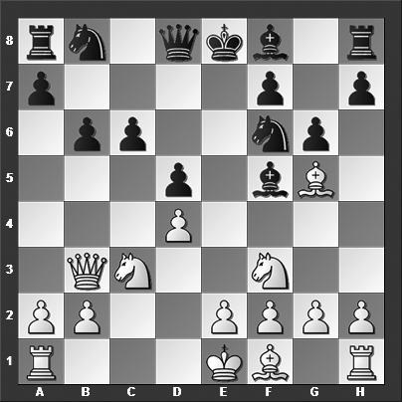

*This is a big mistake on Black's part. How should White best take advantage of the situation?*

8...b5?? is just as bad, e.g., 9.e4 Bxe4 10.Nxe4 dxe4 11.Ne5 Qe7 12.Nxc6 Nxc6 13.Bxb5 Rc8 14.Rc1 Qd6

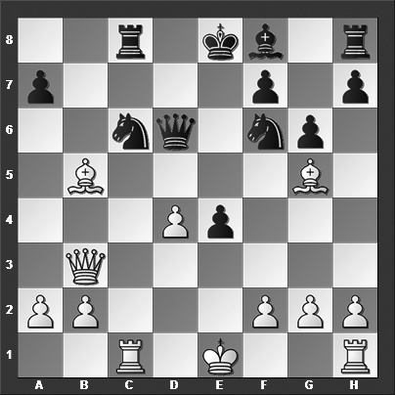

*How should White continue?*

15.d5?? (The simple win was 15.Bxf6 Qxf6 16.Bxc6+ Rxc6 17.Qb8+ and Black is lost0 15...Nxd5 16.0–0 Bg7 17.Rfd1 and White wins his piece back with the clearly better chances, Høi-Kristensen, Silkeborg 2008.

**9.e4!**

Just like that! The pins and other weaknesses in Black's position become more apparent and it is, in fact, impossible to hold everything together without material losses.

**9...dxe4**

One of the crucial points arise after 9...Bxe4 10.Nxe4 dxe4 11.Ne5 Qe7 12.Qh3!! (if 12.Bc4, then 12...Qb4+ 13.Ke2 Qxb3 14.axb3 Bg7 15.Bxf7+ Ke7 allows Black to get away with "just a terrible" position) 12...Bg7 13.Qc8+ Qd8 14.Qxd8+ (Not 14.Qb7? 0–0 15.Qxa8 Qxd4 16.Nc4 Ng4 17.Be3 Nxe3 18.fxe3 Qd7 and Black is doing fine) 14...Kxd8 15.Nxf7+ Kc7 16.Nxh8 Bxh8 17.Bc4 and White is up an exchange with the better position.

**10.Ne5 Be6 11.Bc4!**

White has another option in 11.d5!? Bxd5 12.Nxd5 cxd5 (or 12...Qxd5 13.Bxf6) 13.Bb5+ Ke7 14.Bd7!! (The flashiest move, but also the simpler 14.Rd1! Ke6 15.Qh3+ Kxe5 16.f4+ exf3 17.Qxf3 Bb4+ 18.Ke2 is equally effective) 14...Nbxd7 15.Qxd5 (15.Nc6+ also wins) 15...Qc7 16.Nxd7 Qxd7 17.Bxf6+ and it is completely over for Black.

**11...Qe7**

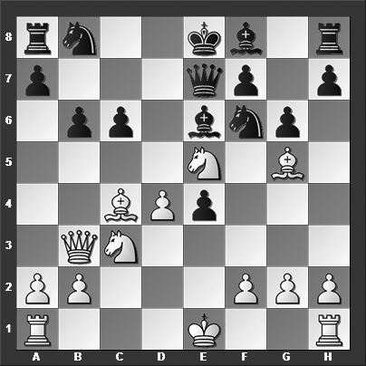

*How should White best continue?*

**12.d5!**

An alternative is 12.Bxe6 fxe6 13.0–0 Bg7 14.Nxe4 0–0 15.Rfe1 with an unmitigated position disaster on the table. The game was soon over: 15...Re8 16.Re3 b5 17.Rae1 a5 18.Nxf6+ (18.Nxg6! is even stronger) 18...Bxf6 19.Bxf6 Qxf6 20.Ng4 Qg5 21.Rxe6 Rxe6 22.Qxe6+, and Black resigned, 1–0, Andersson-Huss, Biel 1977.

**12...Bc8 13.Nxc6 Nxc6 14.dxc6 Bg7 15.Nd5** And Black had enough.

**1–0**

# **From Chapter 4**

# **Semi-Tarrasch & Semi-Slav**

**Game # 94**

**D.Miedema (2368) – V.Burmakin (2553) D45**

Vienna 2016

**1.d4 Nf6 2.c4 e6 3.Nf3 d5 4.Nc3 c6 5.e3 Nbd7 6.Qc2 Bd6 7.e4 dxe4 8.Nxe4 Nxe4 9.Qxe4 Bb4+ 10.Bd2 Qa5 11.c5**

The text move is spending time on a project that should have waited until White had brought the king to safety. The main line is 11.Bd3 c5 12.a3 (White has also tried the very optimistic 12.0–0–0!? Bxd2+ 13.Rxd2 Qxa2 14.Re1 h6 15.Ne5 Nf6 16.Qf4 cxd4 17.g4 with a strong initiative for White to compensate for the pawns, Plachetka-Diesen, Odzaci 1978) 12...Bxd2+ 13.Nxd2 cxd4 14.Qxd4 Ne5 (or 14...Qe5+ 15.Qxe5 Nxe5 16.Ke2 Bd7 17.Rhd1 Ke7 18.Nf3 and here a draw, while early wasn't entirely premature, agreed upon, ½–½, Vavrak-Beck, Pardubice 2008) 15.Be2 0–0 16.b4 Rd8 17.Qe3 Qc7 18.0–0 b6 19.Rac1 with a small plus for White, Goldwaser-Mosquera, Mendes 2009.

**11...0–0 12.a3 Bxd2+ 13.Nxd2**

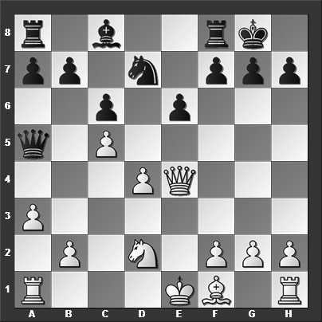

*What is Black's best move?*

**13...e5!**

Breaking up the center, taking advantage of White's underdeveloped forces and unsafe king.

**14.0–0–0?! exd4 15.Nb3**

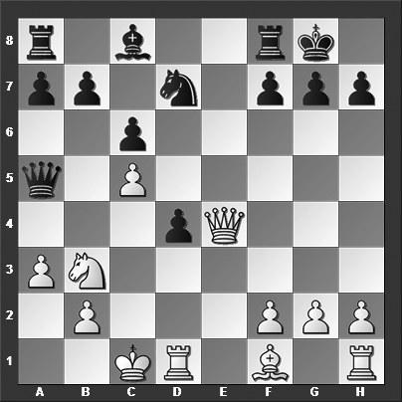

*This is the move White had banked on when playing 14.0–0–0 - what did he miss?*

**15...Nxc5!** And here White resigned prematurely. White had clearly missed this counterpunch and threat to White's own queen. After 15...Nxc5! 16.Qxh7+ Kxh7 17.Nxa5 Ne6 Black is "only" up a pawn.

**0–1**

# **From Chapter 5**

# **Queen’s Gambit Classical Main Lines**

**Game # 105**

**T.Hillarp Persson (2493) – W.Arencibia Rodriguez (2521) D61**

Bled Olympiad 2002

**1.d4 d5 2.c4 e6 3.Nc3 Be7 4.Nf3 Nf6 5.Bg5 0–0 6.e3 Nbd7 7.Qc2 c5 8.0–0–0 cxd4 9.Rxd4 Qa5**

Black has a couple of alternatives at this point:

9...dxc4 10.Bxc4 Qa5 11.Rhd1 h6 12.Bh4 Bc5 13.R4d3 a6 14.Kb1 Re8 15.a3 Bf8 16.Rd4 b5 17.Ba2 Rb8 with chances to both sides, Kiselev-Danielian, Moscow 1996.

9...b6 10.cxd5 Nxd5 11.Nxd5 exd5 12.Bxe7 Qxe7 13.Bd3 Nf6 14.Kb1 Bb7 15.Qd2 Ne4 16.Bxe4 dxe4 17.Rd7 Qe6 18.Ng5 Qf5 with about equal chances, Bellon Lopez-Gil Capape, Oropesa del Mar 1996.

**10.cxd5 exd5 11.h4 Nb6**

11...Bb4 12.Nd2 Bxc3 13.bxc3 Nc5 14.Bxf6 gxf6 15.Nb3 Qa3+ 16.Qb2 Nxb3+ 17.axb3 Qc5 18.Bd3 Be6 19.Kd2 and White has the upper hand thanks to his safer king and superior pawn structure, Rogozenco-Stanke, Hamburg 2003.

**12.Rf4 Bd6**

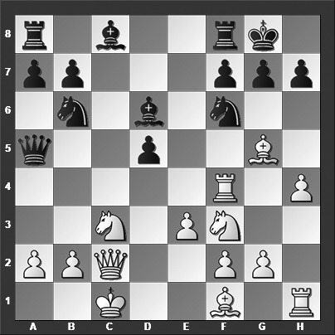

*How should White continue?*

Black has some other moves to consider as well:

The sharp 12...Be6!?: 13.Bxf6 Bxf6 14.Ng5 Rfc8 15.Qxh7+ Kf8 16.Nxe6+ fxe6 17.Kd1 Rxc3 18.bxc3 Qxc3 with complications.

12...Nbd7 13.Bb5 Bd6 14.Ra4 with marginally better chances for White.

**13.Rxf6! gxf6 14.Bxf6**

There's no defense for Black. The immediate threat is Ng5.

**14...Nd7 15.Qf5** Black resigned because after 15.Qf5 Nxf6 White has 16.Qg5+ Kh8 17.Qxf6+ Kg8 18.Qxd6 and the kingside attack isn't even over.

**1–0**

# **From Chapter 6**

# **Queen’s Gambit Specialties**

**Game # 119**

**S.Gordon (2521) – E.Berg (2623) D08**

Hastings 2009

**1.d4 d5 2.c4 e5 3.dxe5 d4 4.Nf3 Nc6 5.a3 Nge7 6.b4 Ng6 7.b5?!**

This is a poor move and a strange decision by the English grandmaster who must surely be aware that the main line continues with 7.Bb2 a5 8.b5 Ncxe5 9.Nxe5 Nxe5, and now:

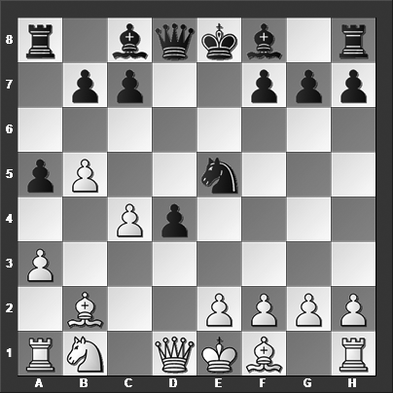

10.Bxd4 Nxc4 11.e3 Be6 12.Qc2 Nd6 13.Bd3 (or 13.Nd2 Qd7 14.a4 Nf5 15.Bc3 Bb4 16.Be2 0–0 17.0–0 Rfd8 with chances to both sides, although I would prefer White's position, Khismatullin-Potapov, Sochi 2016) 13...Qg5 14.Nc3 Qxg2 15.0–0–0 Qh3 16.Kb1 a4 17.Ne4 Qh5 was Gelfand-Morozevich, Astana 2012, and now White should have continued with 18.Nc5 Bd5 19.Rhe1 with a sharp position and chances to both sides.

10.Qxd4 Qxd4 11.Bxd4 Nxc4 12.e3 Be6 13.Be2 a4 (13...0–0–0 14.0–0 Kb8 15.Rc1 Nd6 and Black has more or less equalized, Wojtaszek-Morozevich, Doha 2016.) 14.0–0 Na5 15.Nd2 f6 16.Rfc1 Kd7 17.Bd1 Nb3 18.Nxb3 axb3 19.Rcb1 Rxa3 20.Rxa3 Bxa3 21.Bxb3 Bxb3 22.Rxb3 Bd6 and Black has the slightly better chances in the endgame thanks to his queenside majority, Mikhalevski-Kriventsov, Schaumburg 2006

**7...Ncxe5 8.Nxd4 Bc5 9.Bb2**

Or 9.e3 Bg4 10.Qd2

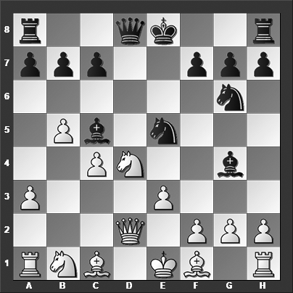

*How should Black take advantage of his lead in development?*

10...Nh4!! (The immediate threat is ...Bxd4 followed by ...Nhf3+, winning White's queen) 11.Qc3 (Or 11.Qb2 Bxd4 12.exd4 Nhf3+ 13.gxf3 Nxf3+ 14.Ke2 Nxd4+ 15.Kd3 Nb3+ 16.Kc3 Bd1! and it is game over for White; also 11...Nxg2+ wins for Black) 11...Bxd4 12.exd4 Nhf3+! 13.gxf3 Nxf3+ 14.Kd1 Nxd4+ 15.Kd2 0–0 and White's king is stuck helplessly in the center waiting for Black to strike decisively, e.g., 16.h3 Bf3 17.Bb2 Qh4 18.Kc1 Rad8 and White has no defense.

**9...Qh4!?**

9...Nh4! is once more annoying for White. 9...Nxc4! 10.Bc3 Qh4 is also very good for Black.

**10.e3 Bg4 11.Qc2 0–0–0 12.Be2**

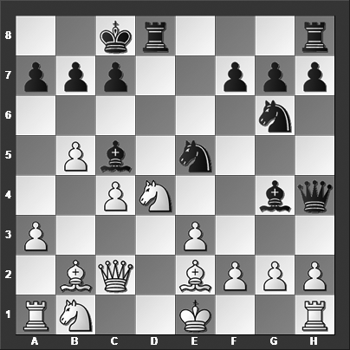

*How should Black continue?*

The text move is a blunder. But even the better 12.Nd2 Rhe8 is quite uncomfortable for White.

**12...Bxe2 13.Qxe2 Bxd4 14.Bxd4 Rxd4! 15.exd4 Qxd4** And White resigned because of 15...Qxd4 16.Ra2 Nf4 17.Rd2 Ned3+ 18.Rxd3 Nxd3+ 19.Kf1 Nf4 20.Qg4+ f5 21.Qxf5+ Kb8 22.Qc2 Rd8 and White loses material.

**0–1**

# **From Chapter 7**

# **1 d4 d5 Specialties**

**Game # 138**

**E.Bareev (2669) – H.Nakamura (2816) D02**

Las Vegas 2015

**1.Nf3 d5 2.d4 c6 3.Bf4 Qb6 4.b3 Nf6 5.e3 Nh5!?**

5...Bg4 is far more common, e.g. 6.Be2 Nbd7 7.h3 Bxf3 8.Bxf3 Qa5+ 9.c3 g6 10.0–0 Bg7 11.c4 and White seems to have the better of it, Sanikidze-Azaladze, Tbilisi 2015.

**6.Bg5 h6 7.Bh4 Nd7 8.Ne5?**

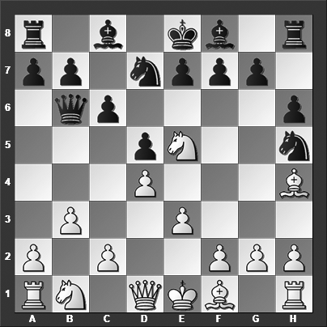

*How does Black refute White's move?*

**8...Nxe5 9.Qxh5**

9.dxe5 Qb4+ is obviously embarrassing.

**9...Ng4!**

This is the star move. Suddenly, White's queen is in peril.

**10.Bg3**

White should have played 10.Bd3 g6 11.Bxg6 fxg6 12.Qxg6+ Kd8 and White has some but of course not full compensation for the piece.

**10...g6 11.Qh4 Bg7** Saving the queen will cost too much material, and therefore White resigned.

**0–1**